**Applied Industry Project : Stock Trading Bot**

**Group A3 – [Br@in]**

Benny, Abin

Birru, Shivaganesh

Bhatt, Jaldhi Himanshu

Duarte Junior, Fabio

Patel, Manali Shaileshkumar

Applied Industry Project – 2024, Loyalist College in Toronto

AIP Project Advisor: Mr. Usman Ahmad

AIP Coordinator: Mr. Stanley Chor

April 08, 2024

# Abstract

Stock trading involves the movement of trillions of dollars being invested daily with millions of decisions made by both humans and automation systems. The competitive landscape is extremely high, and traditional automation tools serve merely as triggers for user-predefined decisions. Thus, based on this scenario, we were challenged by the college to build a Stock Trading Bot based on Deep Reinforcement Learning techniques (referred to in this document as DRL), a solution aimed at modernizing existing technology. It would be capable of automating high-frequency trading using state-of-the-art technology, reducing risks, and increasing returns, with the goal of surpassing current technologies.

In conducting a study on market pain points and how AI has been applied in other sectors, parallel discussions also raised questions such as "Are AI solutions, like trading automations, increasing the gap between the rich and the poor?".

Therefore, we decided that our solution should not only modernize current solutions but also be accessible by reducing the complexity of the trading process to democratize access to our platform.

Our project was based, for the most part, on the pre-existing work of the AI4Finance-Foundation through its research, papers, and Python libraries made available in its open repository. This details our approach, focusing on technological innovation and the democratization of access to AI, based on the FinRL, FinRL-Meta, and FinGPT libraries to create not just a stock trading bot but a more comprehensive trading platform based on AI and cloud technologies.

Table of Contents

Abstract 2

Introduction 4

Literature Review 7

Stock Market domain and available technologies. 7

Regarding insights and compliance. 10

Methods 11

FinRL and Deep Reinforcement Learning (DRL) 11

Exploring Libraries 11

FinRL and FinRL-Meta 11

ElegantRL 12

Deep Q-learning and other approaches from scratch 13

FinGPT 13

Deep Reinforcement Learning Algorithms 14

Available algorithms and their characteristics 14

Available Datasets 15

Testing FinRL 16

Training and testing the agents: 18

A2C (Advantage Actor-Critic) 19

DDPG (Deep Deterministic Policy Gradient) 19

PPO (Proximal Policy Optimization) 19

TD3 (Twin Delayed Deep Deterministic policy gradient) 20

SAC (Soft Actor-Critic) 20

Trading (testing) 21

Architecture 22

BrainLib 24

Batch Process 25

Findings 28

Hidden Overfitting 28

FinRL Installation and alternatives for CUDA 29

Creation of our own version of FinRL : FinRL-Mini 31

Ngrok https tunnel 33

Discussion 35

Our final product 35

Disclaimers and important point about the use of AI. 36

Simulation API running on AWS. 37

Motivation 37

BrainAPI Architecture 38

Swagger documentation 40

Walking though the Features 41

Main Page 41

UI Responsiveness 43

Subscription and Payment methods 44

Logged Session 45

Dashboard 46

Stock Marketplace 46

Manage Bots 47

View Assets 48

Run Simulation 48

AI Knowledge Hub 49

Profile 50

Conclusion 51

Wrapping up 51

Acknowledgement 51

Disclaimer 51

Recommendation 52

References 53

# Introduction

The stock market is highly sought after as an option for asset generation, especially in the current economic situation. For example, research conducted by the website Finder shows that 26% of Canadians turn to the stock market for long-term savings purposes between 2022 and 2023. (King, R. (2023, May 10) Statistics and facts about the stock market. Finder Canada. https://www.finder.com/ca/stock-trading/stock-trading-statistics) [04].

On the other hand, the same research indicates that 37% of Canadians lack confidence in the trading market [04], which is understandable given the volatility and inherent risk of this niche, as well as the amount of financial education needed, an overload of information, and the necessity to closely follow every change happening through news related to target companies or via information providers. In summary, there are many opportunities for expansion in this market if the trading process can be somehow simplified and/or made more accessible to the public, thus also easing life.

To achieve this goal, technology plays an essential role, especially when we talk about optimizing strategies in the complex and dynamic context of the Stock Market. Thus, guided by our Project Advisor, we explored the use of AI techniques based on the Deep Reinforcement Learning approach, inspired by the work of the AI4Finance-Foundation[01,02,03], to create an automation capable of performing stock trading, or as the Project Charter defines, “high-frequency trading.”

Nevertheless, as already mentioned, our objective is not only to automate these operations but also to democratize the use of these technologies and the stock trading market. Therefore, we attempted to wrap around our solution in a platform with an easy-to-use interface and features that assist and instruct the user to optimize their experience and results when using our solution.

To achieve our goals, we utilized the following technologies:

* **Markov Decision Process** (MDP) through Deep Reinforcement Learning. (For the stock trading bot)
* **Natural Language Processing** (NLP), through the RAG (Retrieval Augmented Generation) technique, which combines simpler NLP techniques to identify user intent with APIs of Large Language Models (LLM) for user-friendly responses (For the Chatbot Aka AiKnowledgeHub)
* **FinRL & FinRL Meta**, a Python library made available by the AI4 finance team, used to train, test, and as a basis for creating simulated trading environments. [01,02,03],

We also used some free APIs and external data as follows:

* **Alpaca API** – For news and real-time stock prices and Exchanges.[21]
* **Finnhub API** – For obtaining news data and financial indicators of symbols for the batch process that populates the database.[23]
* **Cohere API** – API and library for accessing the LLM model “Command,” to be used by the chatbot. [22]

The following cloud technologies were also used to execute our solution:

* **Firebase** – Part of the Google Cloud Platform, responsible for database authentication (Firestore).[24]
* **AWS Cloud** – We used a free tier EC2 server to run our chatbot and our simulation feature based on historical data.[20]
* **Vercel** – We used Vercel, in the free tier, to execute our front-end. Vercel is a cloud platform with deployment integrated with GitHub, which greatly facilitated our work.
* **GitHub** – Used as a repository for our project with deployment integrated with the Vercel platform.
* **Ngrok** – This is an HTTPS “tunnel” used to convert our HTTP application to HTTPS for free and with few restrictions. This tool provides a fixed domain and an HTTPS tunnel application that can link any flow from a local server to the HTTPS port of your domain.[05]
* **Nginx -** Advanced Load Balancer, Web Server, & Reverse Proxy
* **Gunicorn -** Gunicorn is a HTTP server for WSGI applications.
* **Yahoo! Finance** – We used data extracted from this platform to train our DRL model and to execute simulation functionalities based on historical data and trading simulation. The data used are the symbols of the Dow30, a “portfolio” of the top 30 symbols selected as a market reference by Dow Jones.

# Literature Review

## Stock Market domain and available technologies.

As previously mentioned, our project was inspired by the work of the AI4Finance team, primarily through the FinRL, FinRL-meta, and FinGPT libraries[01,02,03],. However, before initiating any development or solution design, we needed to deepen our understanding of the market. For this purpose, we utilized the Investopedia platform. Investopedia serves as a database of articles about the financial market at large and is respected by numerous entities such as the Gramercy Institute, SABEW, and the Financial Communications Society, having received awards from these entities in 2020, 2021, and 2022[14]. Its articles are also cited in the financial sections of major news portals like NBC News, CNBC, and Yahoo Finance.

Given its undeniable credibility, editorial standards, fact-checking, and many other mechanisms to keep information as reliable as possible, we used it for research on understanding the business, market volatility, and specific terms of this domain. We observed that the information obtained from the mentioned sources and the way technology is being approached are in resonance with what is currently being used in the market. For example, the use of the volatility indicator VIX as a tool to measure market sentiment and future volatility [15,16,17]. We note that the implementation of AI4Finance papers uses this type of approach for paper-trading model training. According to our interpretation, these data demonstrate that one of the market's major concerns is volatility, and various strategies and indices have been created, such as the VIX, on how to address this issue, which is reinforced by the technical papers researched. It's worth mentioning that we also spent extensive time conducting tests and following the various tutorials available on GitHub and the official page of the FinRL library.

For a broader view, we also consulted research sources that specifically demonstrated how people who are not considered professional traders view the market. Our research team discovered some data on this in the research conducted by the award-winning personal finance writer and real estate expert, Romana King(2023) [04], where she summarizes data from other research conducted between 2022 and 2023, stating relevant points like:

* "41% — Of [Canadian] investors do not invest in the stock market".
* "1 in 4 — Canadians were not confident in the stock market in 2022".

*According to King, R. (2023, May 10). Statistics and facts about the stock market. Finder Canada. https://www.finder.com/ca/stock-trading/stock-trading-statistics. [**04**]*

To shape our technical design approach, we studied the AI4Finance team's papers from 2020, 2022, and 2023 (they mention 2024, but the publication date is in 2023) [01,02,03]. They explain the need for more advanced techniques to optimize trading strategies even in a dynamic environment. Besides discussions on the subject, they present a solution, a set of solutions encapsulated in the form of two libraries with complete tools for historical data manipulation, DRL agent training, and various simulated trading environments, some with integrations to external brokers' APIs like Alpaca. Please refer to the reference section

To date, they maintain and update these libraries through a community with the principle of bringing state-of-the-art AI solutions to the financial market.

In summary, the researched data seem to indicate that trading market professionals are always looking for ways to mitigate the problems caused by market volatility. Investors, both professional and Canadian respondents in the surveys, are fearful or somewhat reluctant to invest in stock trading. On the other hand, there are studies, research, and a community leveraging modern technology for financial purposes addressing the same problems mentioned and maintaining an open-source community. Unfortunately, within the time constraints we had for research, we did not find a viewpoint in the literature that could contrast with what we found during this phase to have a more sober view on the topic. However, given that the use of AI4 Finance solutions was a project requirement and the research aligns with what they publish in their papers, we understood this to be sufficient to validate and clarify the directions and forms the project should take.

Thus, we combined the knowledge from these market research with the available technical knowledge on state-of-the-art (SOTA) AI technology to design a system that was simple to use, yet powerful, but could be executed within the constraints of our course, such as not having financial or technological support, having to use our own resources and freely available resources.

## Regarding insights and compliance.

Research was conducted, primarily based on the IIROC (Investment Industry Regulatory Organization of Canada), focused on specific regulations for the use of AI and automation in Canada.

Here are the most important points produced by the research [10,11,12].

**Automated Order System Definition**: System generating or transmitting orders automatically on a pre-determined basis. Encompasses hardware and software, including smart order routers and trading algorithms.

**Market Impact Risks**: High-speed order transmission can quickly impact markets if issues arise. Marketplace participants are accountable for automated order system use, requiring prevention of interference with fair and orderly markets.

**Regulatory Mandates**: Marketplace participants must take reasonable steps to prevent interference. General understanding and annual testing of automated order systems are required.

**Confidentiality Considerations**: Acknowledgment of confidential client information but emphasizes the need for a sufficient level of knowledge to manage risks.

**Fair and Orderly Markets Support**: Provisions aim to support fair and orderly market functioning upon deploying smart order routers, trading algorithms, or other automated order system aspects.

**Risk Mitigation Controls**: Requirement for controls, including a "kill switch," to disable malfunctioning automated order systems promptly.

**Essential Market Functioning**: Recognition of the necessity of controls in mitigating risks posed by automated order systems to market functioning.

# Methods

## FinRL and Deep Reinforcement Learning (DRL)

The cornerstone of our project is the use of FinRL and its other components for the training, testing, and trading process of the DRL agents that are responsible for the trading transactions.

For this purpose, we based our research primarily on the paper by Liu, X.-Y., et al. (2022), "FinRL-Meta: Market environments and benchmarks for data-driven financial reinforcement learning," presented at NeurIPS, and on the official web documentation of the respective software/libraries.

Through this, we evaluated potential Agents, environments, and libraries.

## Exploring Libraries

### FinRL and FinRL-Meta

These paired open-source libraries provide both a pipeline for creating Reinforcement Learning models and allow the creation of a diverse training environment with a variety of data sources and integration with other libraries. Although the documentation and the library seem a bit outdated, with broken links in the 2021 documentation (see the references section) and version conflicts during installation, we were able to install and test their capabilities. Currently, they seem to be unified, which reduces implementation complexity. After testing and reviewing the papers and documentation, we can conclude that it is a very powerful and flexible library, suitable for our purposes. We will refer to them as one entity throughout the rest of the document. The documentation for the library includes guidelines on how to conduct the installation on AWS Cloud environment and docker image.

It is divided into three layers, transparent to the implementer, abstracting much of the complex training process.

* **Data Layer:** It essentially provides functions to load the data it is integrated with, as well as for data cleaning and feature engineering.
* **Environment Layer**: It creates market environments in the standard used by OpenAI Gym, incorporating specific techniques to simulate real-world markets.
* **Agent Layer**: This is where the DRL algorithms are available, provided through an internal implementation of the ElegantRL library. The algorithms cater to various types of applications, such as stock trading and portfolio management, each with its characteristics, advantages, and disadvantages. However, we tested some using the tutorials provided in the documentation and saw promising results.

ElegantRL

Offers open-source DRL algorithms suitable for both continuous and discrete actions, as well as for multi-agent reinforcement learning scenarios. We indirectly tested some agents from this library via FinRL; however, ElegantRL stands out as a promising option should we choose an environment other than FinRL, such as OpenAI Gym. One notable advantage is that, unlike FinRL which is TensorFlow-based, ElegantRL operates on PyTorch, compatible with our available GPU hardware. Moreover, ElegantRL has minimal dependencies, requiring only Python version higher than 3.6 and PyTorch above 1.0.2, making it more manageable. Therefore, if compatibility issues arise with FinRL, we can utilize ElegantRL independently.

### Deep Q-learning and other approaches from scratch

We came across projects like the trading-bot by Prabhsimran Singh (refer to the reference section), which implements the Q-learning algorithm from the ground up. Although it's not a library by itself, it acts as a benchmark for building from scratch. Nevertheless, we think that replicating such an algorithm would be redundant since ElegantRL already offers an optimized DQN agent with support from the open-source community. Opting for an already established algorithm appears to be more beneficial than developing our own within this constrained timeframe. We also found another intriguing example, built from scratch, which employs a web scraper to fetch data from Yahoo and integrates a news API connection to perform sentiment analysis for making buy and sell decisions. While this approach is interesting, it does not use DRL, which may not align well with our project's expectations.

### FinGPT

FinGPT is an open-source framework designed for Financial Forecasting and Advice, leveraging Natural Language Processing (NLP), specifically Large Language Models (LLMs). Within the scope of our project, it could serve as a Robo-Advisor, aid in Portfolio Optimization, and perform Financial Sentiment Analysis. The tool can be trained out-of-the-box using LLaMA or ChatGLM algorithms, but it also offers the flexibility to integrate with other LLMs, like ChatGPT, via APIs. It utilizes data from news, trends, and social media to create a repository for sentiment analysis. We tested the Robo-Advisor implementation and, although the results were impressive (it searches for news about a company or ticker, then makes a forecast and provides investment advice based on sentiment analysis), the process is time-consuming. This leads us to believe that we might lack the computational resources required to run these more advanced technologies efficiently. We also reviewed the related paper, Yang, H. (Bruce), et al. (2023). FinGPT: Open-Source Financial Large Language Models. https://doi.org/10.48550/arXiv.2306.06031, but have not yet completed our research and understanding of its features.

## Deep Reinforcement Learning Algorithms

### Available algorithms and their characteristics

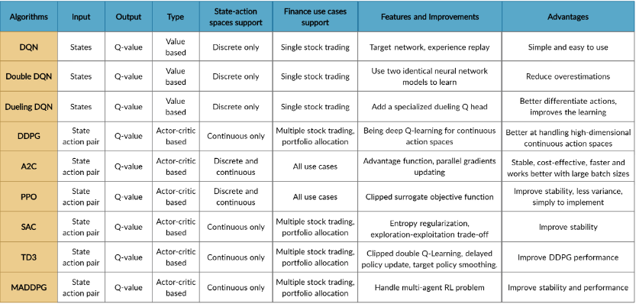

*FinRL. (2021). DRL Agents. Retrieved January 28, 2024, from* [*https://finrl.readthedocs.io/en/latest/start/three_layer/agents.html#elegantrl-drl-library*](https://finrl.readthedocs.io/en/latest/start/three_layer/agents.html#elegantrl-drl-library)

Within the FinRL documentation itself, we found definitions and advice on top state-of-the-art DRL Agents, and to our surprise, the library mentioned already has an integrated implementation of the ElegantRL library and its algorithms, which can be easily implemented. We chose three models to test, using the default configurations from the documentation (refer to the "references" section) with an initial budget of $1000000.00.

The training process took six minutes (on average) for 10 “episodes”. Using this basic configuration, we achieve a very positive result in the training PPO, DDPG, and SAC algorithms.  
With no tunning and a few “episodes” of training over a ten-year time frame on Yahoo Financial data, we get a risk ratio, observed here as Sharpe ratio, within what would be considered "good" in terms of performance.

## Available Datasets

Guided by the FinRL paper, we reviewed the available datasets and chose to use Yahoo Finance for its ease of use and availability. We also encountered the possibility of using an API service called Alpaca, which promises to provide financial data for free for educational purposes and solution development, though we haven't thoroughly explored this option yet. Here is the list of dataset options available within the FinRL environment for reference, but we will primarily be working with Yahoo Finance.

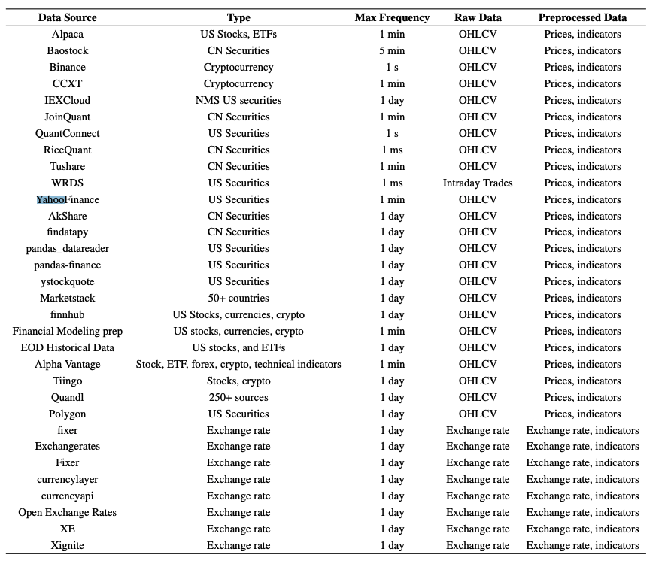

*Liu, X.-Y., et al. (2022), "FinRL-Meta: Market environments and benchmarks for data-driven financial reinforcement learning,"*

## Testing FinRL

As mentioned, we conducted tests on three different types of agents using a training window of ten years of historical data from Yahoo Finance (Dow Jones top 30 tickers) and the standard parameters from the tutorials provided in the official FinRL documentation. To measure the results, FinRL provides some metrics for comparing the models, as follows:

* Cumulative return: R = V- V0/ V0

V = final portfolio value

V0 = original capital

* Annualized return: r = ((1+R) ^ 365/t) -1

t= trading days

* Annualized volatility 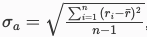

ri = annualized return in year i

ř = avg annualized return

n = number of years

* Sharpe ratio: 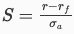 (The Sharpe ratio estimates investment returns versus risk.)

rf = risk-free rate

* Max. drawdown: The maximal percentage loss in portfolio value.

|  |  |  |  |  |  |  |  |  |
| --- | --- | --- | --- | --- | --- | --- | --- | --- |
|  | Annual return | Cumulative returns | Annual volatility | Sharpe ratio | Calmar ratio | Stability | Max drawdown | Daily value at risk |
| SAC | 0.041 | 0.125 | 0.221 | 0.295 | 0.111 | 0.019 | -0.372 | -0.028 |
| PPO | 0.092 | 0.291 | 0.233 | 0.495 | 0.263 | 0.243 | -0.350 | -0.029 |
| DDPG | 0.139 | 0.457 | 0.217 | 0.708 | 0.449 | 0.739 | -0.309 | -0.027 |

With an initial budget of $1,000,000.00 and a runtime between 5 and 6 minutes, we achieved good results both in terms of increasing the value of the assets and with a risk vs. investment ratio very close to the margin between "good" and "high."

For instance, by running the SAC-type Agent after training in an environment simulating a real exchange with a 2-year timeframe (2019-2020), we achieved an estimated return of approximately $3,258,353.00.

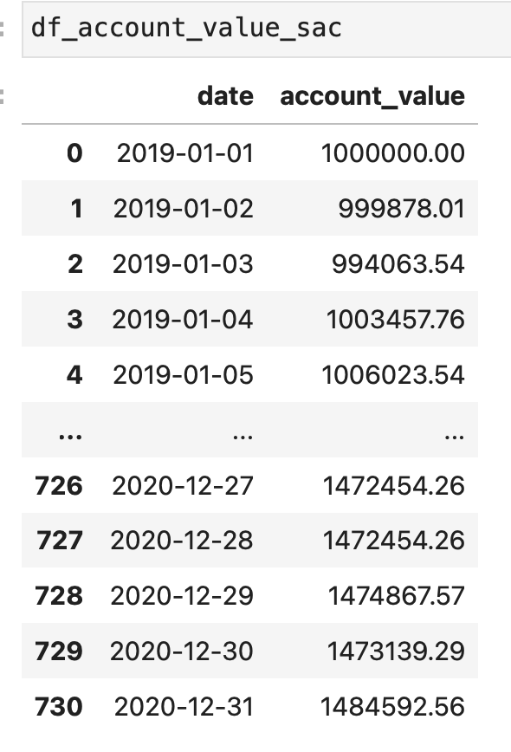

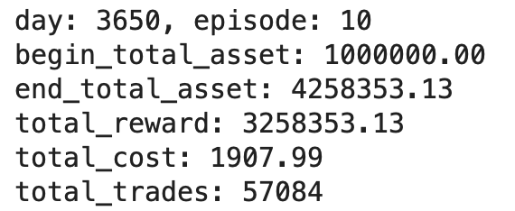

## Training and testing the agents:

**Tickers.**: Top 30 Dow Jones.

**Start**.: 2010-01-01.

**End**.: 2023-12-01 (testing data from 2022 to 2023)

We tested the following agents by varying some hyperparameters and increasing the amount of data compared to the previous version. We used the following agents, utilizing the stable baseline 3 library (initially, we used the elegantRL library but encountered compatibility issues and decided to switch): a2c, ddpg, td3, ppo, sac. The a2c and ddpg agents (which we used in the first prototype) do not have many hyperparameters. In contrast, the td3, ppo, and sac models allow adjustments to the batch size, buffer size, and learning rate.

During training, all of them performed well, with varying execution times for similar configurations. One notable aspect was the SAC model, which initially showed extremely high profits with a Sharpe ratio above 1.0, considered very good. However, as training progressed, these metrics decreased, with the Sharpe ratio seeming to stabilize around 0.8. This could indicate that the initial results were due to overfitting. We plan to explore this characteristic further and measure it more accurately to understand what is happening.

Here are the training results:

### A2C (Advantage Actor-Critic)

Combines value-based and policy-based approaches, using the advantage function to reduce variance.

Execution time : 14.94 minutes

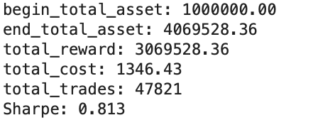

### DDPG (Deep Deterministic Policy Gradient)

Learns policies in high-dimensional, continuous action spaces using off-policy data and the Bellman equation.

Execution time :25.58 minutes

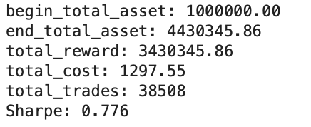

### PPO (Proximal Policy Optimization)

Optimizes policy gradients by maintaining a balance between exploration and exploitation, with simplified updates.

Execution time : 12.35 minutes

Hyper parameters:

"n_steps": 2048,

"ent_coef": 0.01,

"learning_rate": 0.00025,

"batch_size": 128,

"device":"mps"



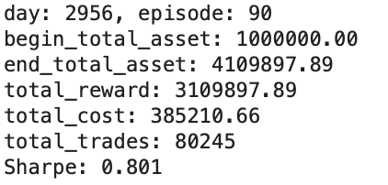

### TD3 (Twin Delayed Deep Deterministic policy gradient)

Improves DDPG by using two value functions to reduce overestimation and delayed policy updates.

Execution time : 25.1 minutes

Hyper parameters:

"batch_size": 100,

"buffer_size": 1000000,

"learning_rate": 0.001,

"device":"mps"



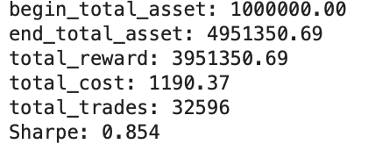

### SAC (Soft Actor-Critic)

Focuses on maximizing a trade-off between expected return and entropy, encouraging exploration.

Execution time : 47.47 minutes

Hyper parameters:

"batch_size": 128,

"buffer_size": 100000,

"learning_rate": 0.0001,

"learning_starts": 100,

"ent_coef": "auto_0.1",

"device":"mps"



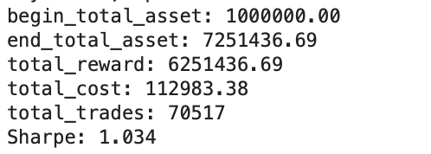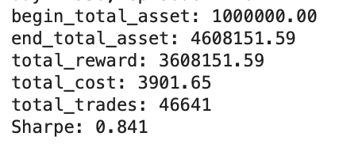

## Trading (testing)

During testing, we also tested with data from 2021-10-01 to 2023-12-01. An interesting observation is that all models, including the average and the Dow Jones Industrial Average (DJI), had a negative peak on 2021-11-10, likely due to some atypical event on that date. In the long term, the PPO model surpassed the SAC agent, but it exhibited much instability; during training, PPO had the highest risk index of all.

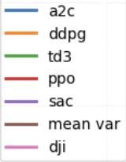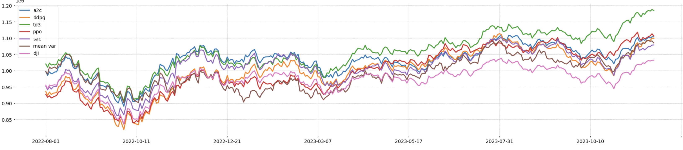

The SAC agent showed the least variation, but its financial gains were not as good as those of A2C and TD3.

The A2C model performed very well, but in the long term, the td3 model showed the best result, with moderate variation and achieving profit most of the time.

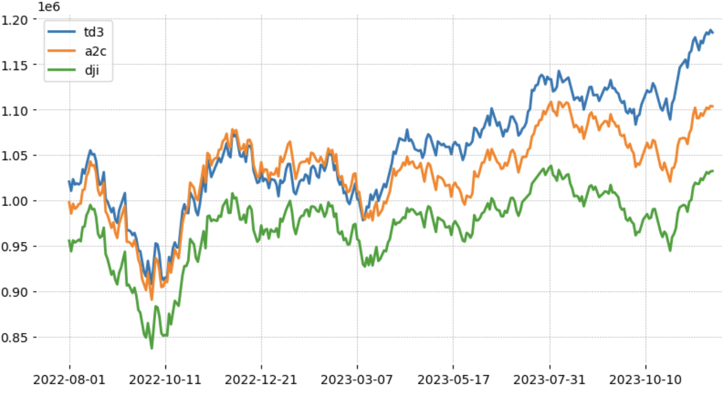

## Architecture

To make all our solutions working together without costs, our application was divided into smaller services, each running in a different environment, but all are interconnected at some point. We are using different cloud solutions in integration with local batch process.

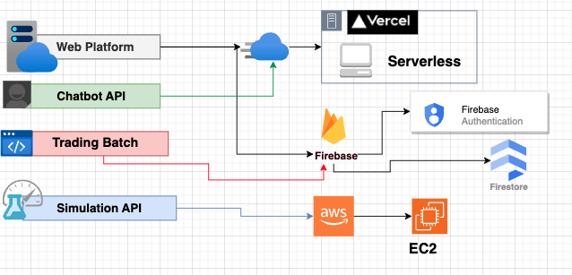

As for the AI Knowledge Hub, part of the Chatbot API, is using RAG architectures by using Coherer’s API for the LLM and Finnhub to generate financial information in the batch process.

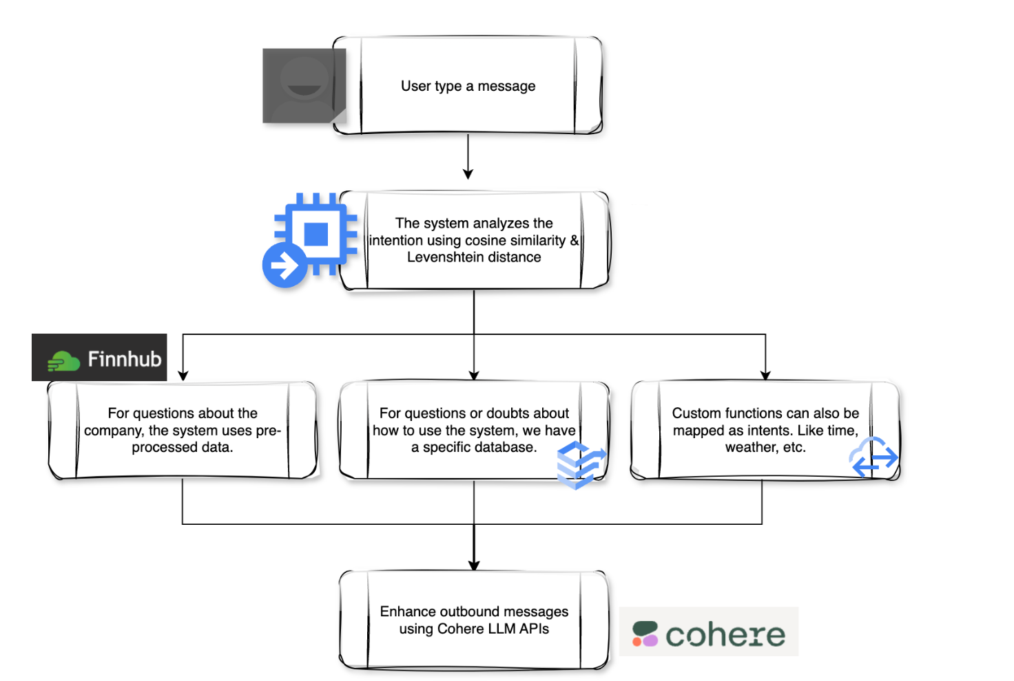

## BrainLib

We created this library to facilitate development, the complexity of the code, and the number of libraries we use because of FinRL (for example). We encapsulated the main functions by organizing our library as follows:

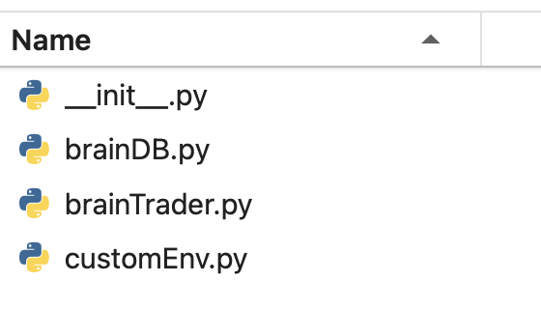

**BrainDB.py** -> Contains simplified functions for accessing data in local and cloud databases already with connection settings. As in the example above, to check the data of the bots in the cloud, it is only necessary to create an instance of the brainDB.FireStoreDB class and then call the list_bots() function. It's that simple.

**CustomEnv.py** -> This is the class containing the most recent version of our customized FinRL-meta environment.

**BrainTrader.py** -> This is the class that controls the integration between data, agent, and environment. It encapsulates complex tasks and libraries necessary for the bot's execution.

In the code snippet below, for example, we are using the brainTrader.GenericTrader class. The GenericTrader class was made to work with customized agents and data. This generalization makes it easier to use different agents and different data files.

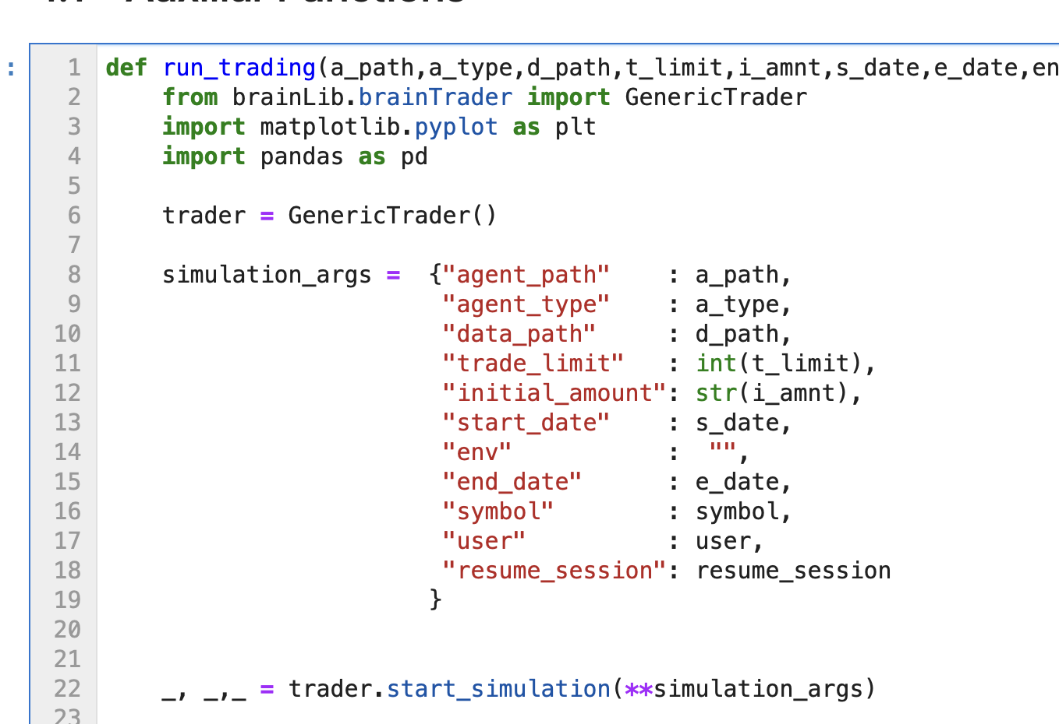

With the GenericTrader class, we just pass the data and call the “start_simulation()” function.

## Batch Process

We are using the Apscheduler library to execute the “run_session” function at a specific frequency. So, every x minutes, the batch process will run the trading based on the information registered by the interface and the data generated in the previous session.

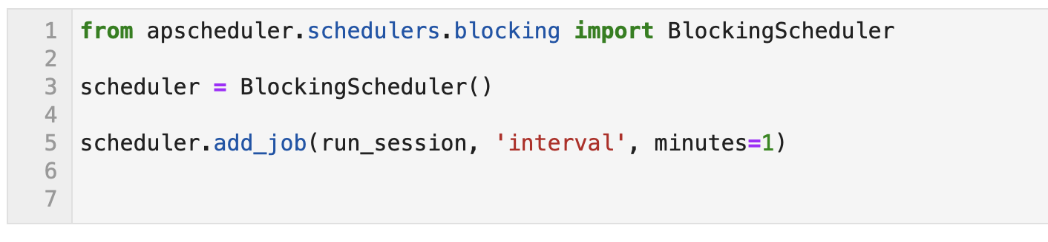

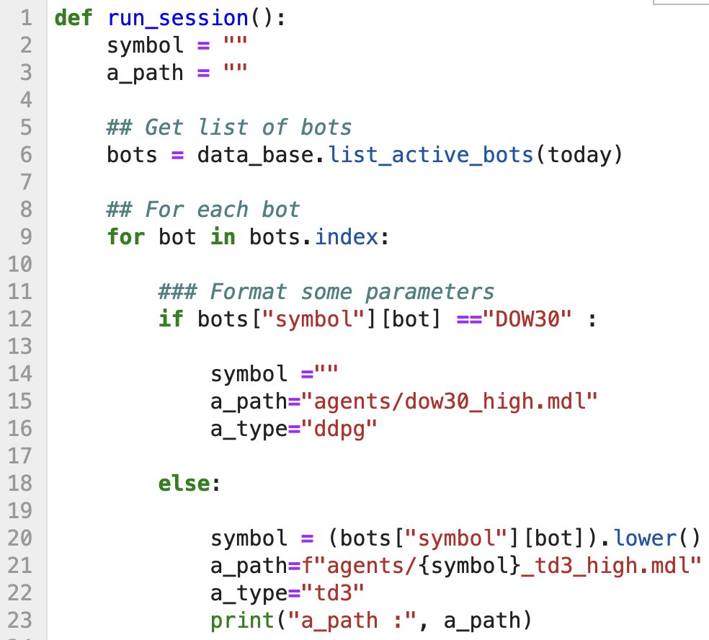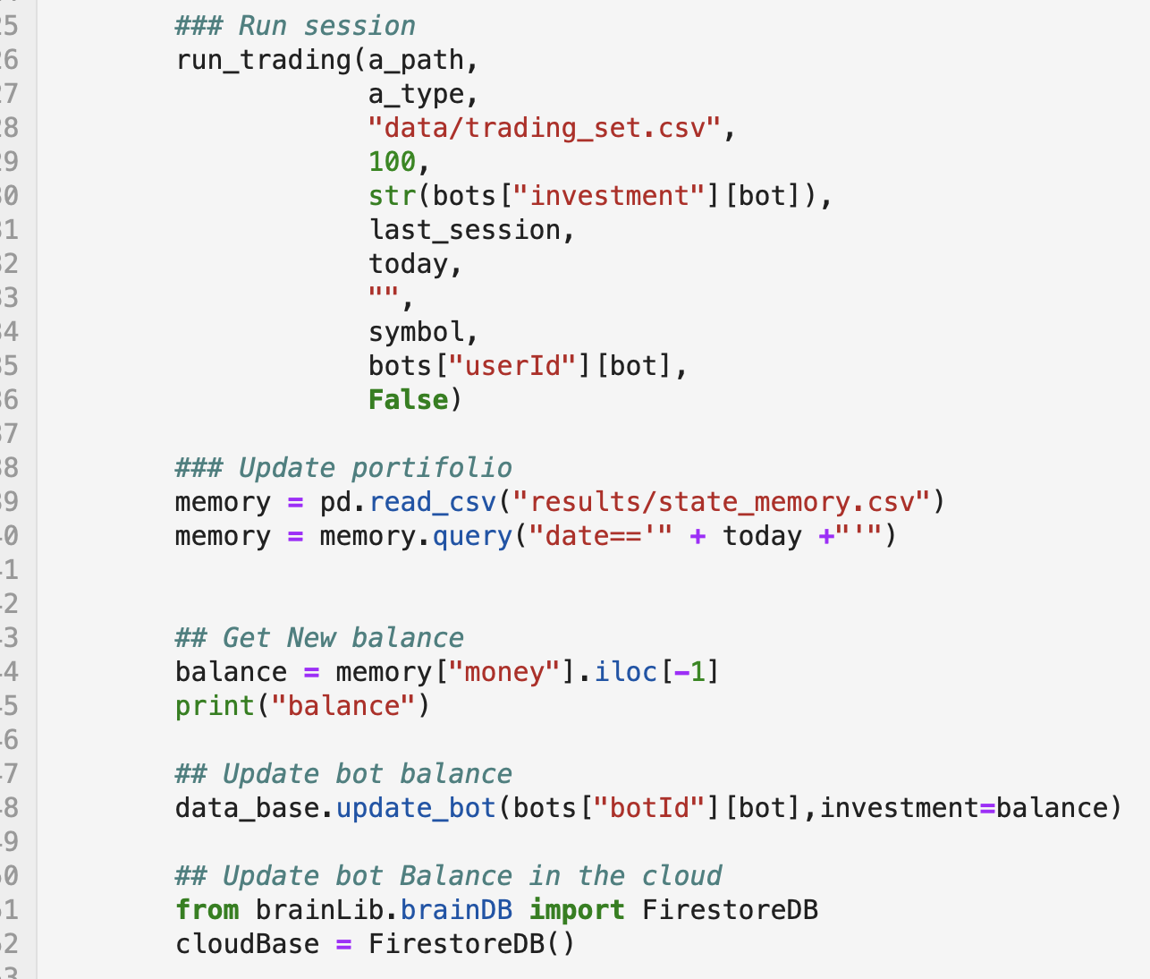

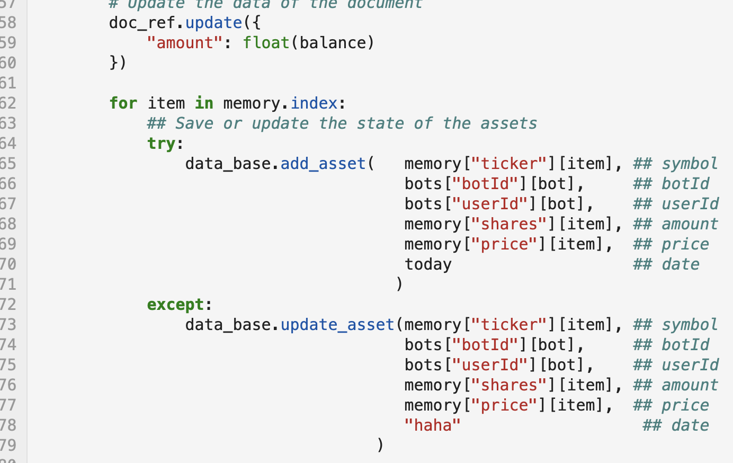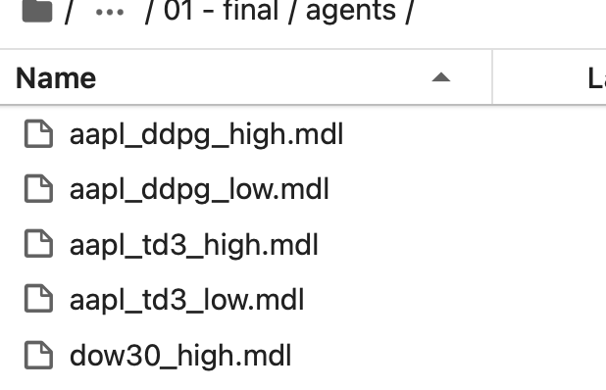

The run_session function loads the list of information for all buttons that have not yet expired. Subsequently, the function checks whether it deals with multi-trading or single trading, and then, based on the value and type of trading, it selects a model that has been refined for that situation. For example, if the user chooses the ticker "AAPL" and allocates a high amount, the function will use the aapl_td3_high agent. After that, the trading is executed, with the session log saved in a CSV file. The function then concludes by reading the log file, updating the cash balance, and adding to the database the record of the number of assets purchased in the session and their values. Example of a record of the user's bot assets from a session for a bot running for all the tickers of the Dow 30:

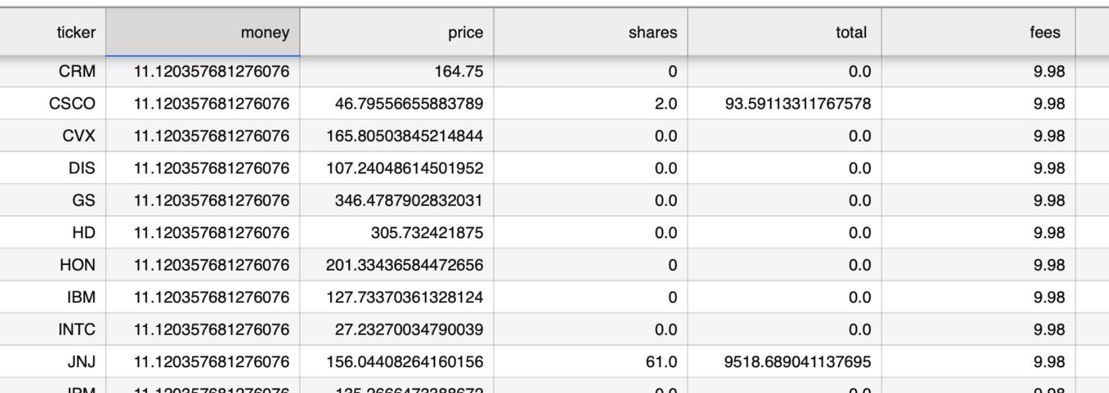

Outcome of the batch execution for the example we registered in the user interface (demonstrated at the beginning of this document):

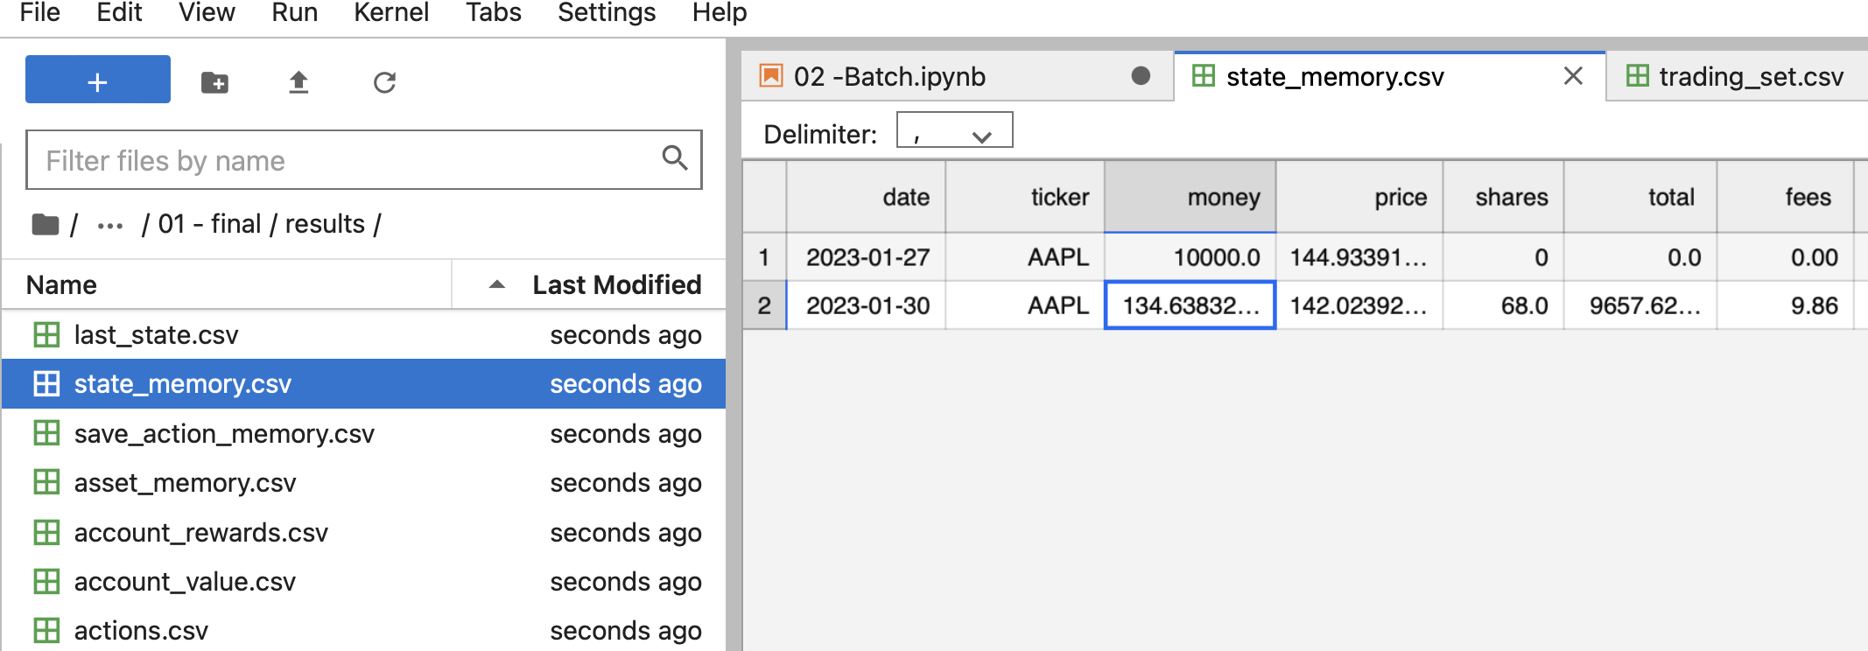

The batch process outcome displays the state of the previous session:

AAPL, $10,000 available for the bot to trade, the ticker's price on that day, and the number of shares the user held on that day, followed by the next row representing the trading day. In the second row, one can observe that the money now is the remainder from the day's transactions. We also have the share amount, the total asset value (number of shares * ticker price), and the total fees paid in the transactions for that session.

# Findings

## Hidden Overfitting

It's very easy to fall into overfitting, although it's hard to identify clearly.

As noted in previous sections, when we tested the models, the results were quite impressive. We were able to increase our portfolio value by more than fourfold using models that were trained for just a few minutes over a 10-year period of historical data.



When we apply these types of models to more recent test data, they end up performing well, though not as promisingly as in the training phase. However, it's noticeable that they become "biased" towards certain symbols, keeping them in the portfolio even when their market value is declining. It's as if they learn something along the lines of "holding Apple stocks is always good; they will always perform well."

In summary, great care must be taken when tuning these models, as it's possible to fall into the "illusion" that they can perform very well when, in fact, they are being "lazy" or "biased" towards a point of just buying more and more of a stock, even when it's no longer performing well in the present. The solution we found to balance this was to execute several rounds of tuning, carefully observing the behavior and distribution of the portfolio chosen by the model and adjusting the hyperparameters and training iterations.

## FinRL Installation and alternatives for CUDA

We encountered numerous issues with the installation and operation of FinRL-Meta. Apparently, in the last three months, there has been a consolidation of all repositories by the AI4Finance team, resulting in broken or moved links to examples and sources, parts of the source codes being outdated or having conflicting versions of the same classes, bugs, among other issues. Consequently, many of the code examples were also broken, outdated, or incomplete, and it wasn't even possible to run them on Google Collab without making adaptations.

Additionally, the official version of the library is completely outdated. If you try to install it via pip, you will need to downgrade your Python version and many of the main libraries.

We found an installation alternative in the documentation, which was to install directly from the GitHub repository using the pip package manager, which was a pleasant surprise. Thus, by using the command `pip install git+<repository path>`, it's possible to install a library directly from its most recent version on GitHub, without needing any authentication or additional steps. With this information, we managed to install it in the Google Collab environment for testing, and even though we used GPU and TPU, we understood that the training process took a long time to complete.

Among the equipment available to our team were two gaming laptops and two Apple laptops with Apple Silicon (ARM64) architecture. However, it was an impossible task to install the library on Windows due to dependencies on development tools like C++ compilers among other requirements that seemed "strange" to us. Despite much effort, it was not possible, making running the system using CUDA unfeasible since the machines with Nvidia GPUs ran on Windows and even virtual machines couldn't install the entire environment.

Parallelly, based on past experiences in college, we identified that the libraries we were trying to use ran PyTorch behind the scenes, which allows the use of MPS or Metal Performance Shaders, which is Apple's equivalent to CUDA.

Thus, we cloned the FinRL repository and added a command so that the library could now be compatible with the use of MPS, allowing us to run the model training using the GPU of Apple laptops. Then, we used the direct installation feature from GitHub to install the modified library.

The MPS-compatible version of FinRL is available at https://github.com/FabioD-Junior/FinRL and involves a simple line of instruction that was replaced in the paper trading module.

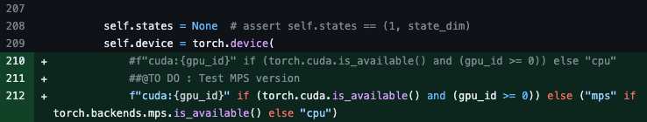

In summary, running a simple basic example of the library for the first time was very challenging, but once we had a complete understanding of what we were doing, we were able to overcome the problem. This made us look at an improvement point that is ignored nowadays and is also not widely disclosed, which is the use of MPS for AI purposes. Most people developing AI solutions with Python are not even aware of this option to replace NVIDIA's CUDA, and due to its ARM64 architecture nature, it consumes much less energy than an approach using regular GPUs. However, we not only applied the use of MPS in our project but also enabled the FinRL library so that other people from the open community can also be aware of and enjoy this alternative.

## Creation of our own version of FinRL : FinRL-Mini

The processes of training and executing DRL agents, especially when there's a large amount of data, require a lot of resources, burdening any basic system. It can present bottlenecks in processing, demanding a long time to finalize processes that seem simple to the user, as well as being prone to memory overflow, disk, or in the case of using cloud technologies, a very high charge if the automatic provisioning of resources is not being well managed and monitored. One point that we are proud of in this project was the ability to use our creativity to circumvent some of these problems and still achieve an excellent result, for example, executing the simulation in a cloud environment (AWS) within the free tier.

After a great effort analyzing the source codes of FinRL, which is available as open source on GitHub, we had the idea to perform "reverse engineering" to understand how this library works and to create a new version containing only what is necessary to specifically execute our purpose. As explained in the previous section, the FinRL library tries to bring the most varied and useful tools for the development of DRL solutions for finance, making it generalist and more specific for training the model and exploration than for the process of executing the created solution. Thus, we cloned the entire library repository and downloaded it locally, removing the components and classes that were used only for training or that were not related to our solution, such as the environment module used to connect with Chinese exchanges, the environment and dependencies used to access the Alpaca environment, methods of downloading data that were not from Yahoo Finance among others. We discovered in this way that this library does not use the common dependency mapping process that we learned in college and are used to, such as the use of requirements.txt, instead, it uses a pair of files to map what must be installed for the library to function. These files are:

* **Pyproject.toml** – Contains the description and metadata of the library, such as the author's name, license, etc., the version of Python compatible with the library, and the main libraries that must be installed first.
* **Poetry.lock** – Responsible for the dependencies necessary to install the main libraries related in the **pyproject.toml**, as well as any other extra dependency (such as examples, templates, etc.).

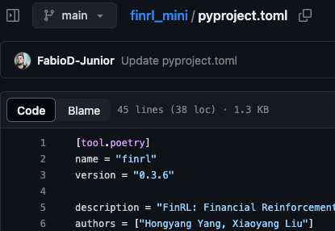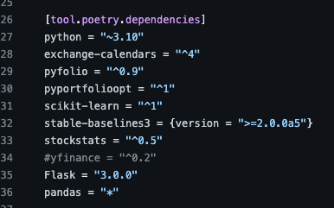

We also made adaptations in these files with the intent of installing only the relevant dependencies and excluding extra dependencies that are never used, for example, one of the libraries has as an extra dependency a gaming environment for Atari, which probably should be used as an example for studying and training agents capable of playing video games.

Our library, FinRL-Mini, derived from the FinRL library is available on our GitHub. We maintained all the original credits and information of FINRL, adding the information that this is a lighter version adapted to run using fewer resources and only for execution, not training models.

It can be installed using the command:

pip install git+https://github.com/FabioD-Junior/finrl_mini/

Once again, through our creativity and problem-solving ability, we managed to contribute to the open-source community while solving a complex problem.

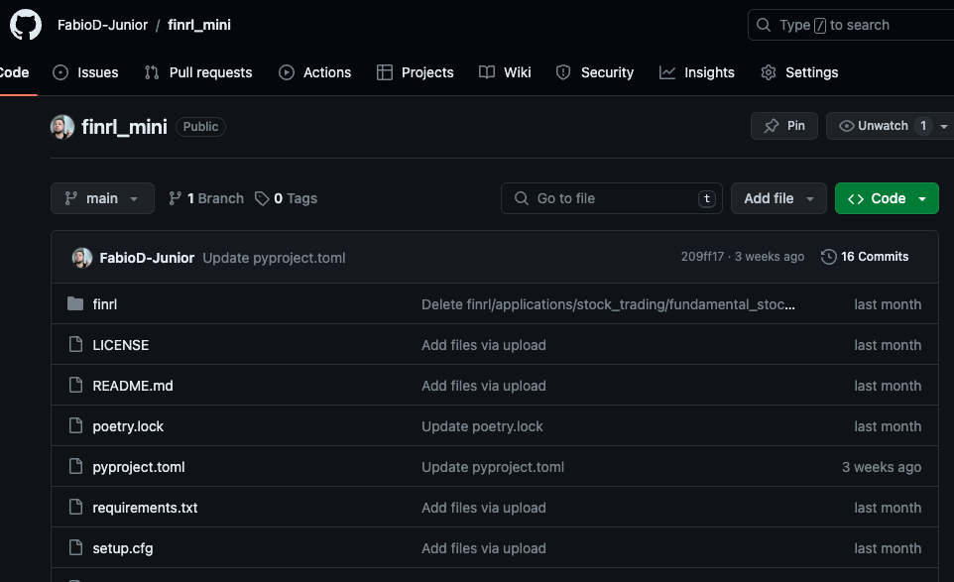

# Ngrok https tunnel

During the deployment of the application, we encountered issues during testing. Unlike running locally, when we run in production, the web interface defaults to HTTPS due to Vercel's cloud configuration. However, the AWS standard, where the backend runs, is the HTTP protocol. To change this setting, it is the developer's responsibility to manually configure and provide the SSL certificate for use in authentication. This situation, where one solution runs on HTTPS and another on HTTP, creates a security error in the browser, preventing the platform from operating properly.

Since we do not have financial resources for this project and are only using free solutions, we did not have the means to purchase a domain and register a digital certificate, nor was our attempt to use a self-signed certificate productive.

After a lot of research, we discovered Ngrok, which is an HTTPS tunnel solution. It converts the entire server flow to a fixed free domain with HTTPS output in real time.

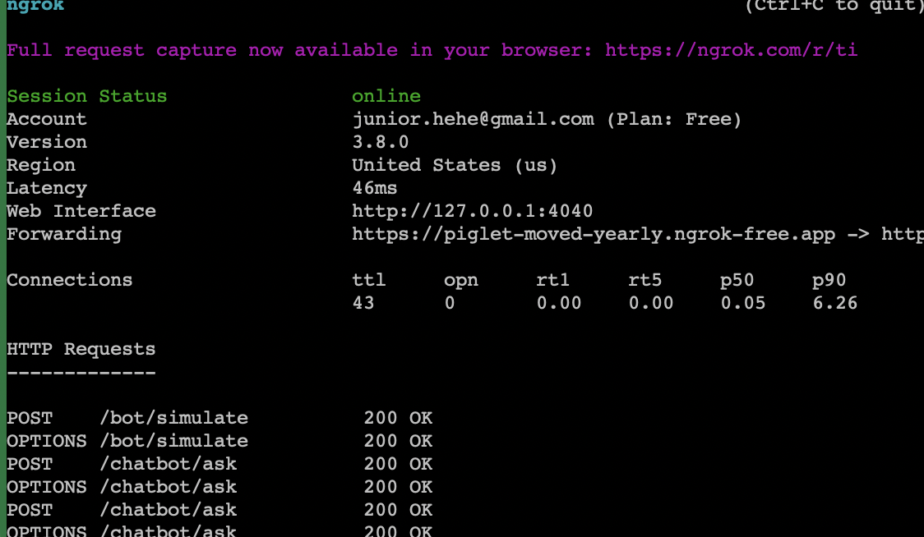

This solution also allows us to observe all the calls made to the endpoint through an intuitive web interface.

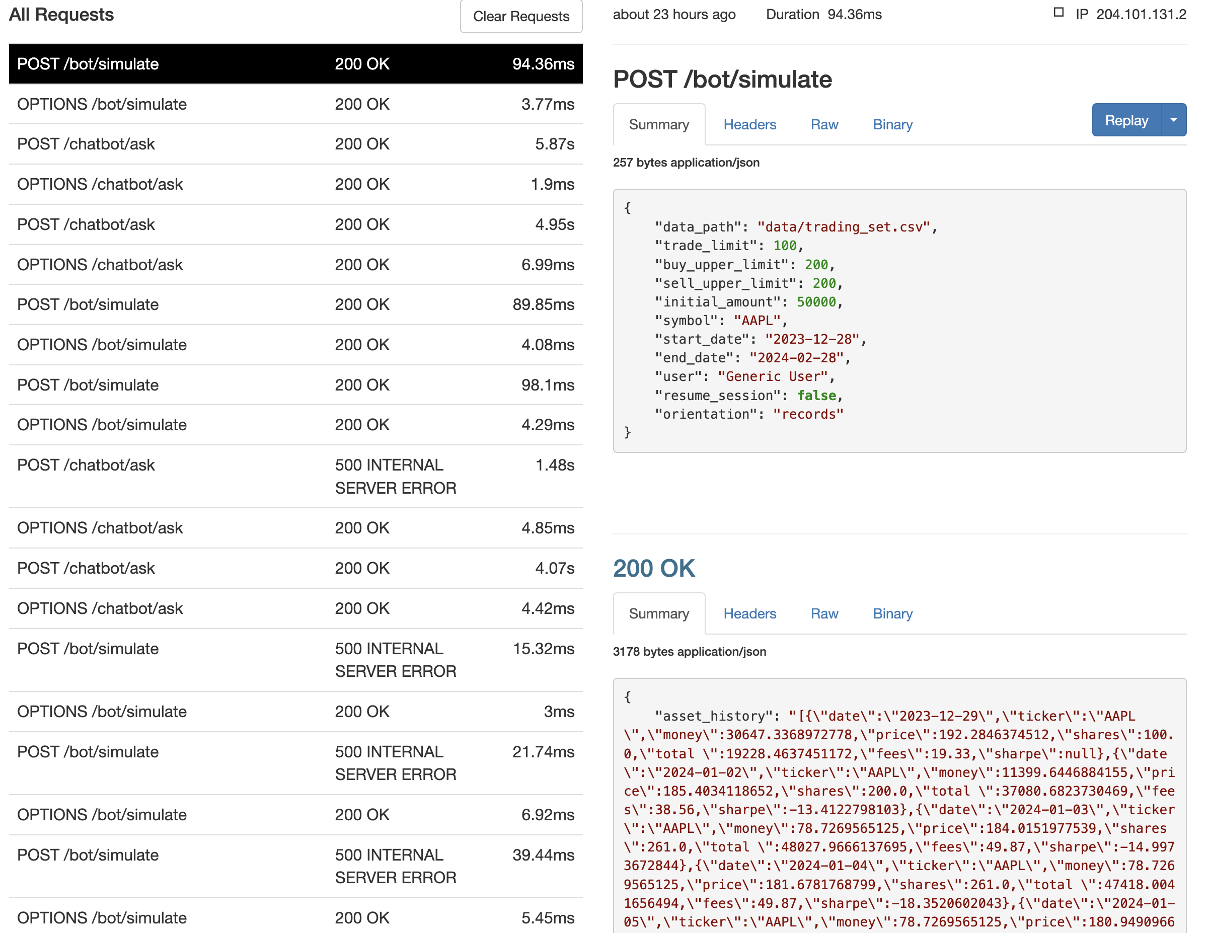

Therefore, we were able to proceed with our deployment using this solution while keeping our entire process running for free.

# Discussion

## Our final product

As already mentioned in the section on the architecture of our solution, guided by our mission to democratize access to trading using modern AI technology while being able to run the system on a structure that had no cost due to the restrictions of this AIP course, we divided the project into modules and created a user-friendly visual interface, well-organized, and easy to use, consolidating the features into a single platform.

We believe that with this we have achieved our objective of bringing modernization and ease to trading, in addition to providing relevant information about the stock market to the person operating the system.

## Disclaimers and important point about the use of AI.

It's always important to clarify that we cannot guarantee profit under any circumstances. What our system does is try to optimize your chances of maintaining as high a portfolio value as possible using AI decision-making techniques. Again, even simulation is not a guarantee of profit or that the system will behave exactly as in the simulation of historical data.

Regarding chatbot functionalities, despite our efforts to keep information up to date and as accurate as possible, the nature of AI chatbots' operation means they have a margin for erroneous responses technically called "hallucination." If you ask a question outside the scope of the symbols and companies we operate with on the platform, you may get results that do not represent the truth. Once again, we emphasize that the chatbot is subject to "hallucinations," and may provide inaccurate or fictional information as if it were real.

## Simulation API running on AWS.

### Motivation

Our first idea was running all features on AWS, but it is not possible due the constraints, in this case DRL takes a lot of memory (mainly) in order to run because of the “state space”, transformed into a numeric tensor(vector/matrix, depending on which naming stand you prefer) grows as the number of symbols and tickers, and the more complex the bigger the size of the trained model. The CPU would not to be a problem since running the already trained model is not heavy in computational terms, different from training which we had to use GPUs for the execution, the mains problem is the memory. We could do that, but it will be costly, to keep the solution running in the free tier of amazon we had to be creative. In the previous sections is cited that our solution is divided into different features, this approach of using multiple modules running in different clouds and environments emerged from this challenge to come up with a solution given the situation of scarcity of computational resources.

This section will present and describe how we used our creativity to create the simulation API, branded as BrainAPI, which is also a product feature offered by our solution where the users within top subscription can have access to implement our solution in their own code or automation.

Since we could not install and deploy FinRL lib on Vercel, due computational resource restrictions, we had to use an alternative where we could have more control over the environment to make the necessary adaptations for everything to work normally. Thus, we used a virtual machine on EC2's free tier running Ubuntu server.

We had to adapt the solution to run with 1GB of memory, so we restricted the number of tickers per simulation to just one and created a light version of the FinRL library.

The result was more than satisfactory, our simulation API can run with all security components, middleware, and API gateway using only 1GB of memory, 1 vCPU, and still achieve a response time of less than 1 second (as you can see in the screenshot below).

### BrainAPI Architecture

We designed the API architecture to be lightweight yet robust. One of our primary concerns was handling concurrent calls. Typically, in AI course activities, the solutions were not designed to be accessed by more than one user simultaneously, nor was there a focus on the security and performance of the application.

We decided to create the API using the RESTful pattern. However, despite applying the main concepts, we had to be flexible in some aspects of it to adapt to our use case. Therefore, we cannot strictly call our API RESTful but rather REST-like, meaning it applies the principles of REST, but some details were not implemented. For example, we had to use only the POST method for some applications that should have used the GET method according to the RESTful standard, due to server limitations or to improve performance in some cases.

That said, our API operates in a stateless manner, meaning there is no specific session, and we do not maintain user data or caches. This is particularly advantageous for scenarios where microservices are implemented.

We implemented a bearer authentication, meaning a user with a valid token can access the application. The token is generated through the login endpoint, where the user enters their credentials and once validated, receives a token with temporary validity.

As mentioned, we needed a robust, multi-user, and secure solution, which could not be achieved using only Flask as the server, as it is intended for testing and development purposes, not production. Thus, we encapsulated Flask within two additional layers: a WSGI to manage multi-user calls and a reverse proxy gateway for access management, call handling, load balancing, and traffic management.

Therefore, we chose the following technologies to complement the API's architecture:

- **Nginx** - For the edge gateway. It serves various functions like load balancing and reverse proxy.

- **Gunicorn** - A **WSGI** HTTP Server capable of running multiple Python processes.

This is the diagram of how these technologies interact within our design.

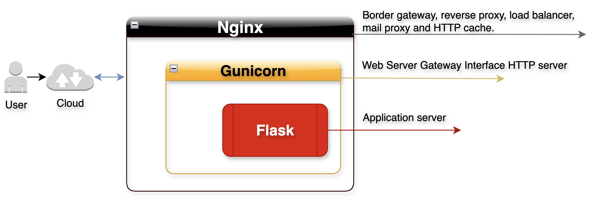

### Swagger documentation

As we would offer this API as a service, our team developed a swagger documentation to help our developer customers.

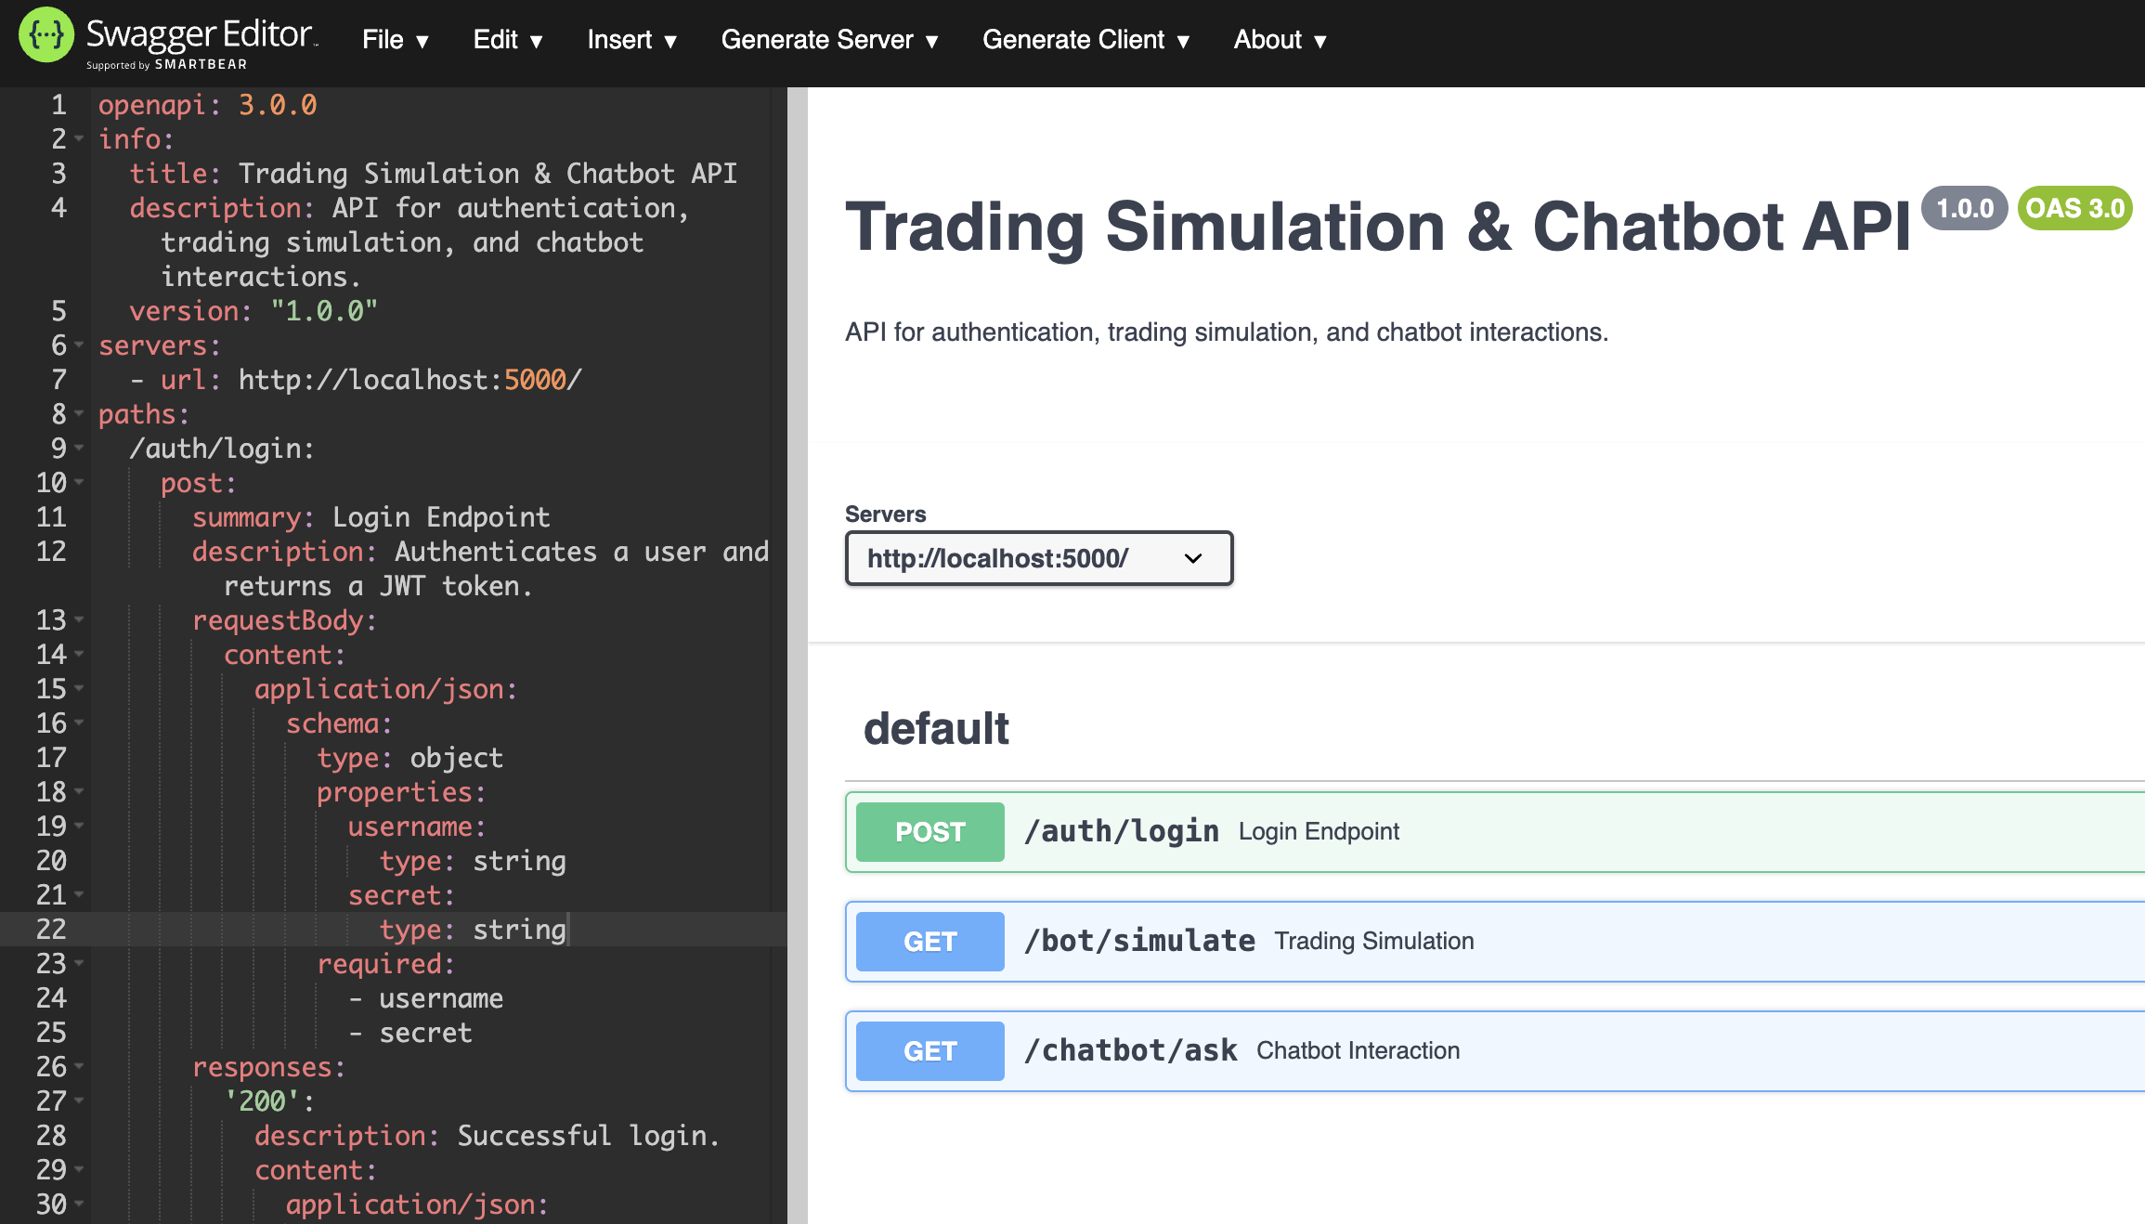

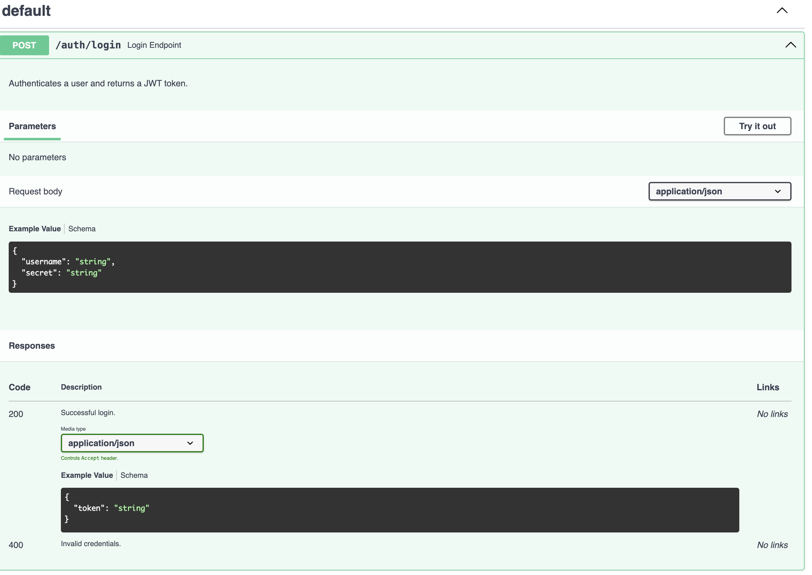

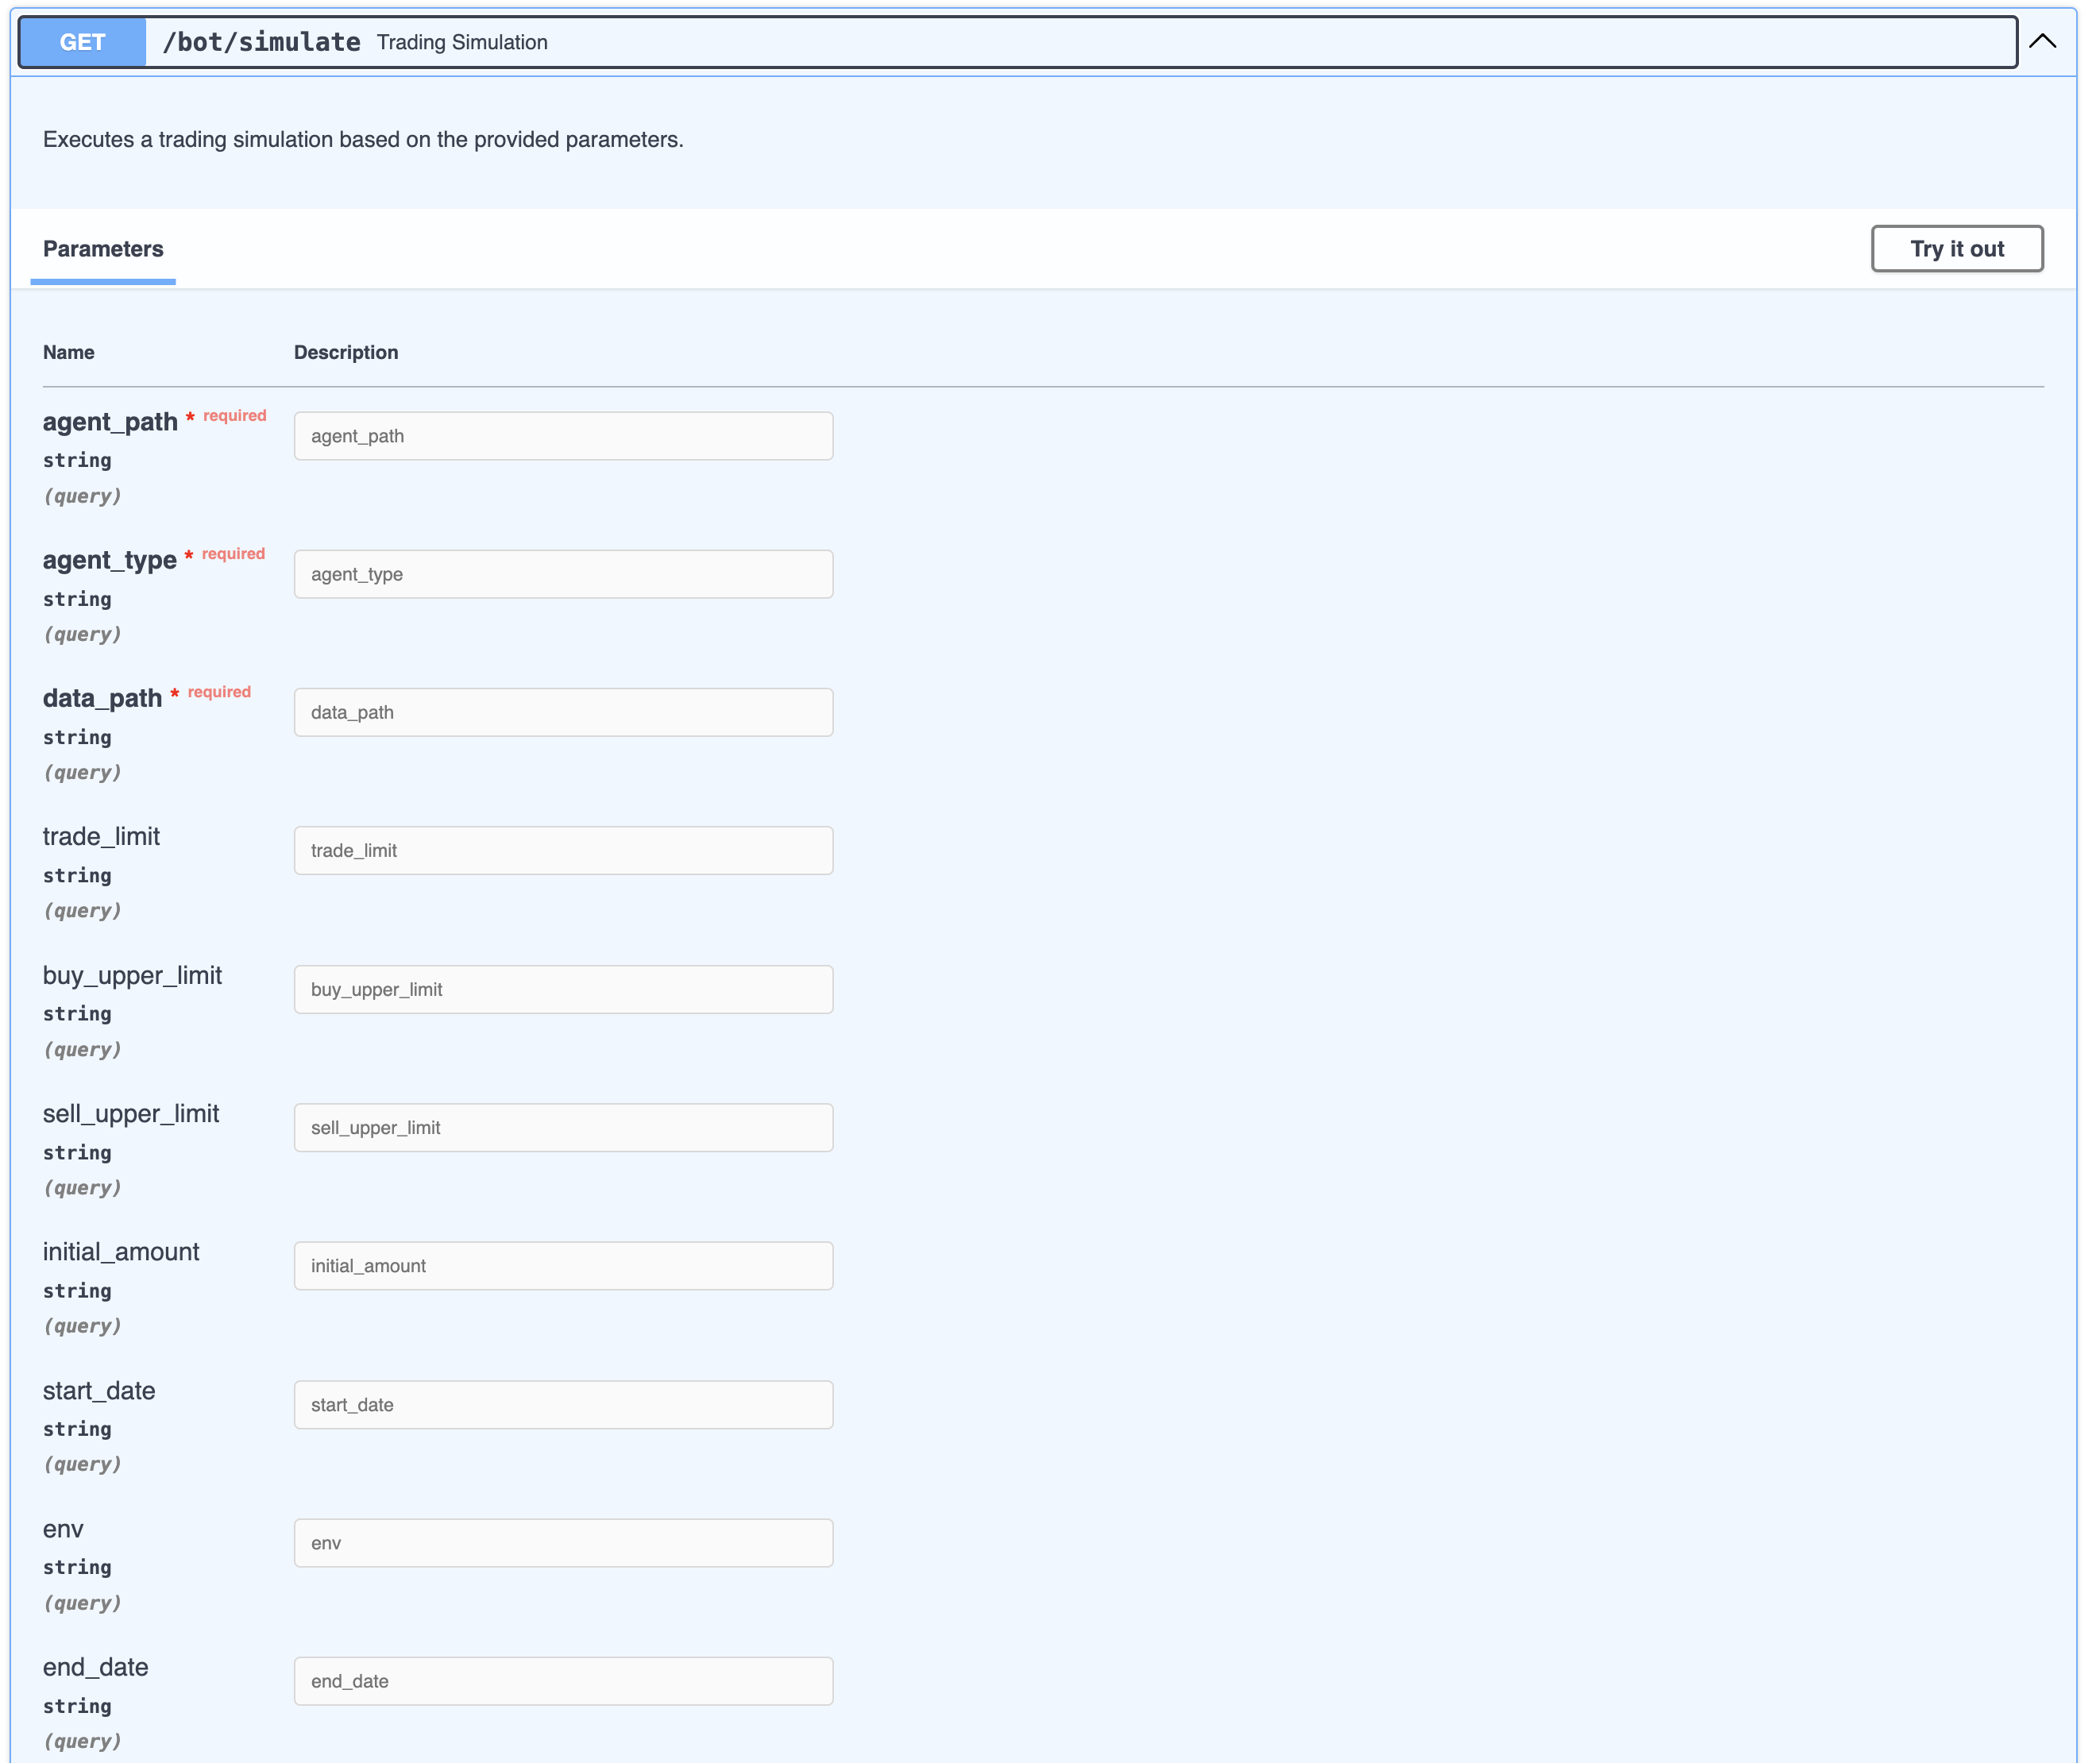 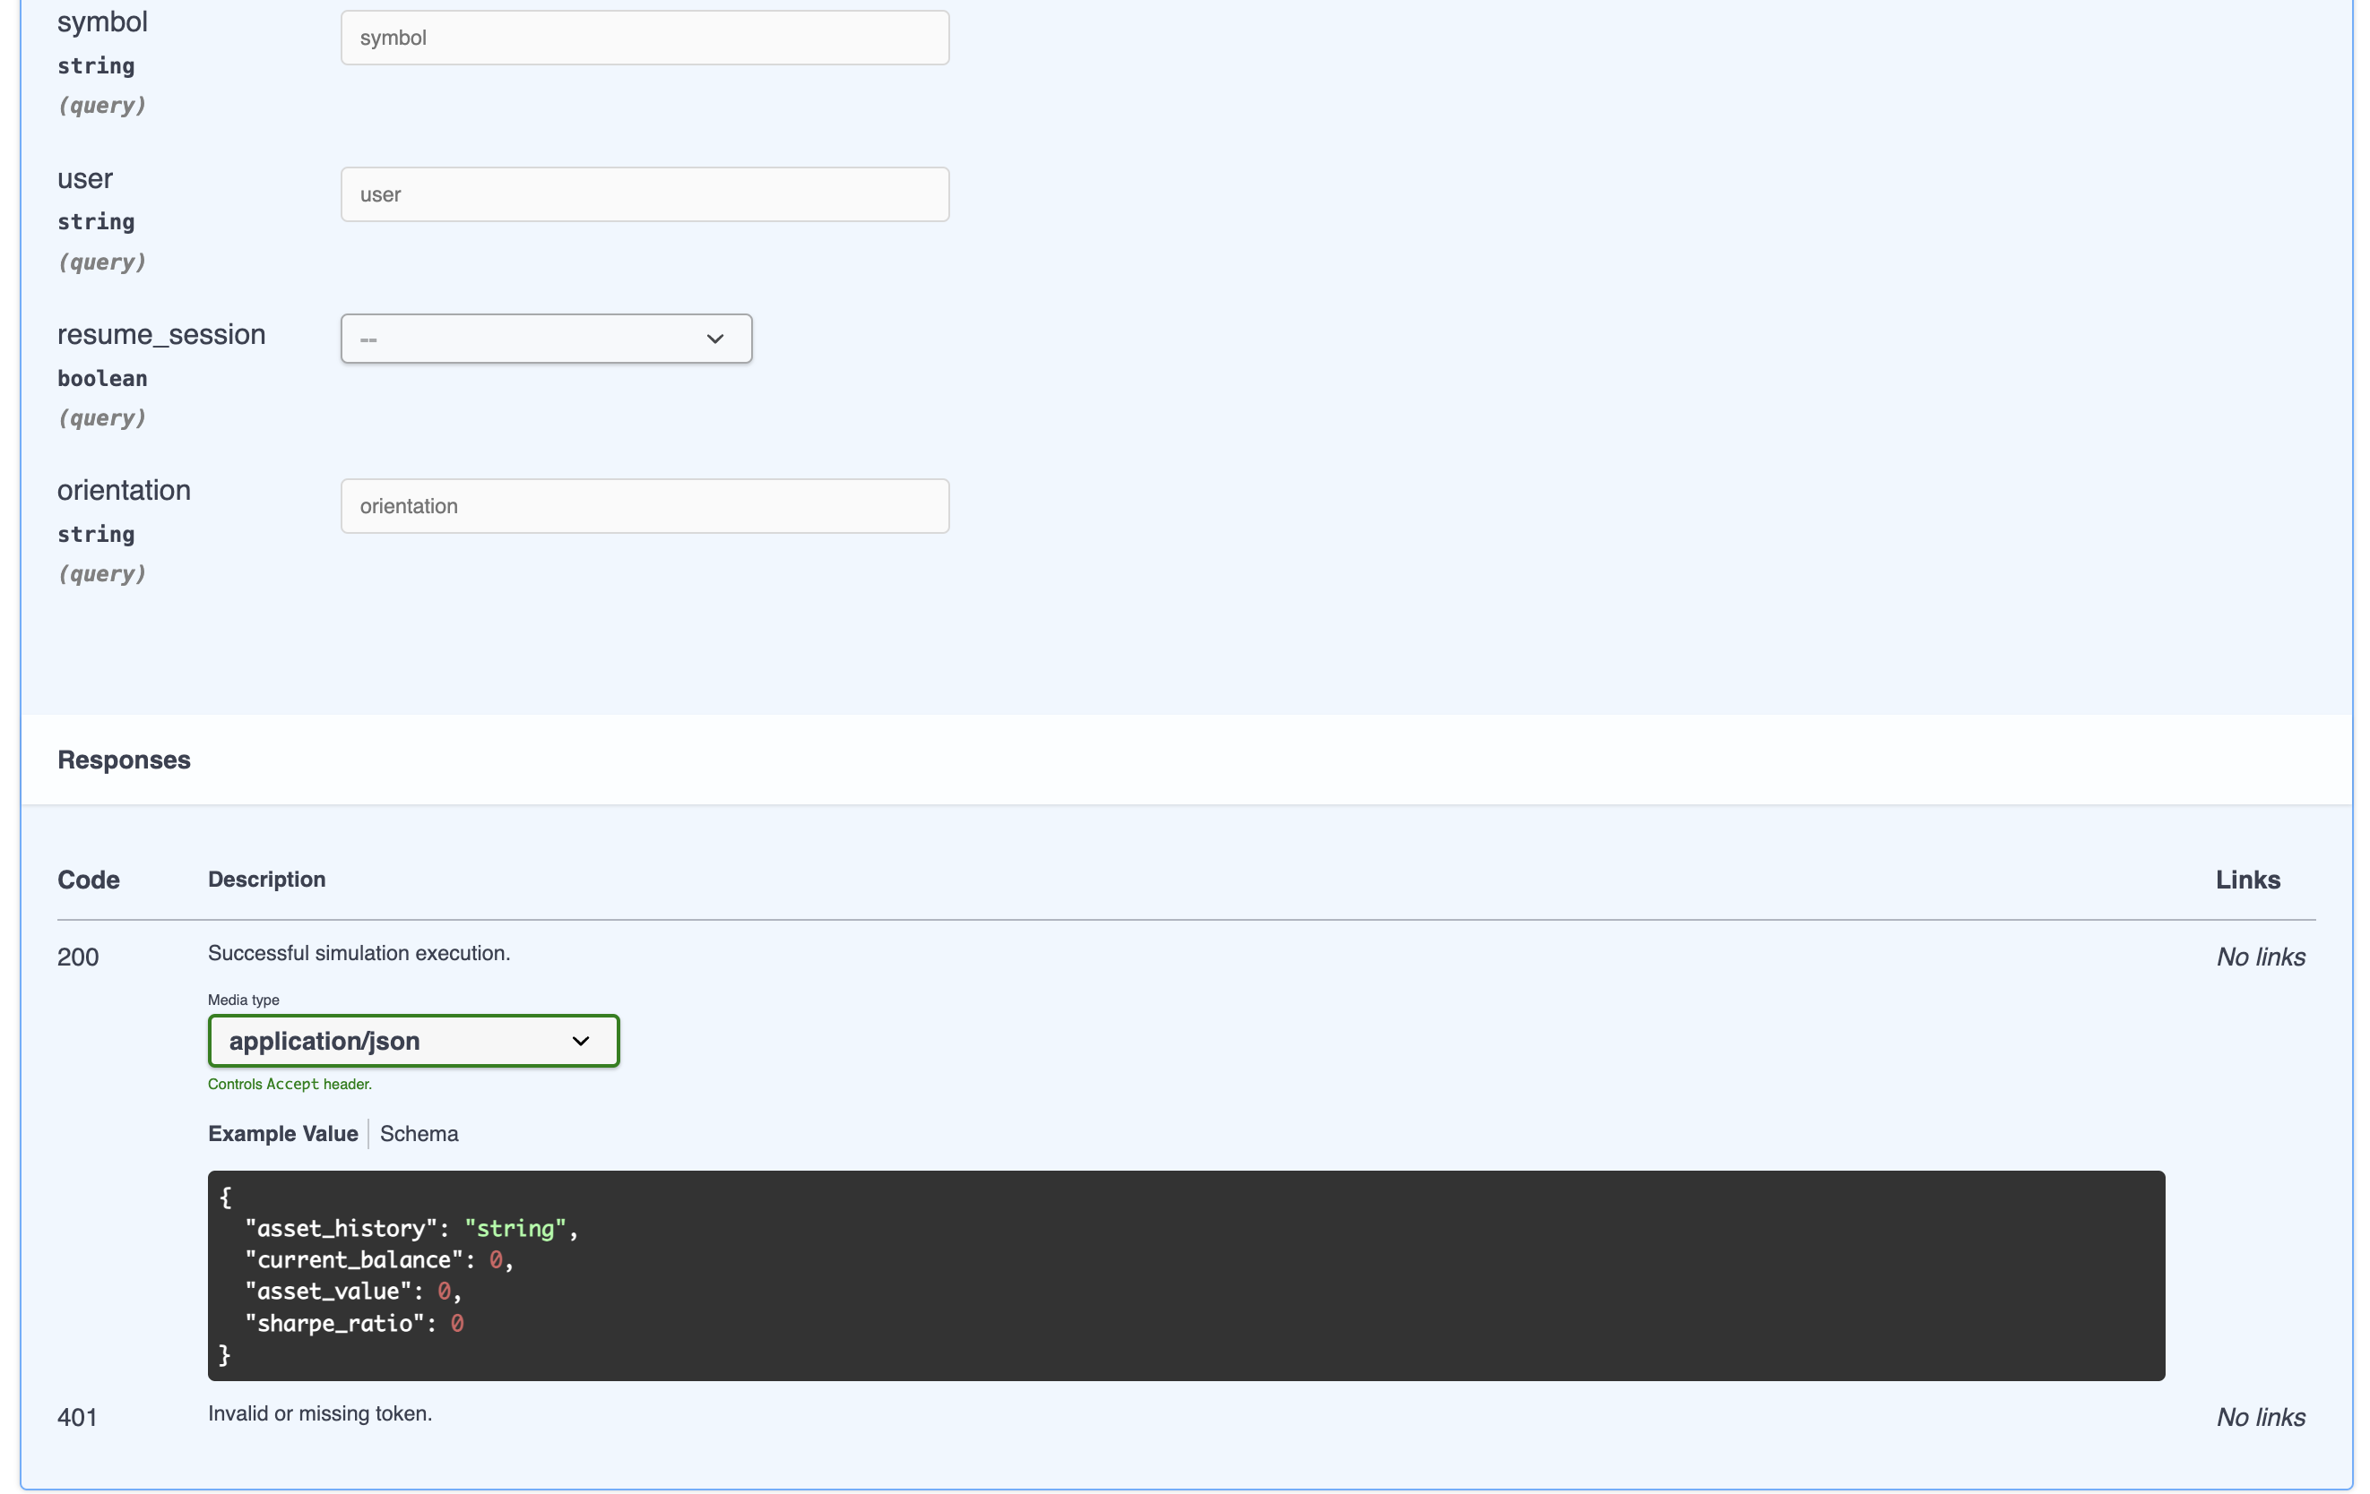

## Walking though the Features

### Main Page

Firstly, you can access the application using the following URL:

<https://brain-trading-bot.vercel.app/> this is the official link to your bot platform.

For more information about our team's features and products, you can visit the official Brain's team page at: https://jaldhihimanshubha.wixsite.com/brain.

Upon accessing the platform, you will find the following page:

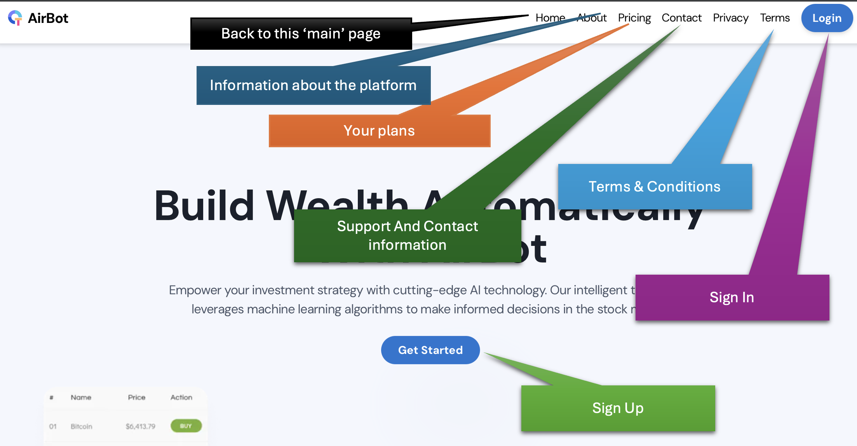

**Home**: Returns to the platform's main page.

**About**: Directs to the About page.

**Pricing**: Displays the page with our subscription plans.

**Contact**: A form to get in touch and ask questions.

**Privacy & Terms:** Terms and conditions of use.

You will also find two buttons: "Login" at the top right corner and "Get Started" at the center of the page.

As a user who already has an account, simply click the first button, and enter your credentials.

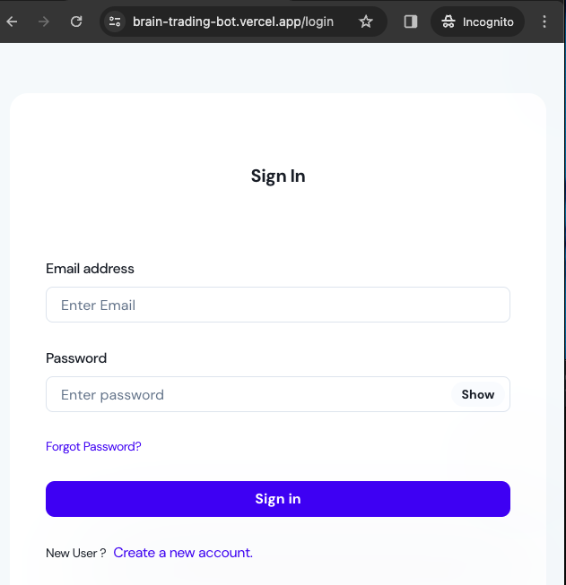

If you are a new user, you can click on "Get Started" and complete your registration in a few simple steps.

### UI Responsiveness

Our platform is designed with user convenience and simplicity in mind. With these ideals, we've created pages that adapt to the size of your device's screen, whether it's a smartphone, tablet, PC, or any other device with a compatible browser.

Below, you can see a simulation of how the page resizing behaves across different devices.

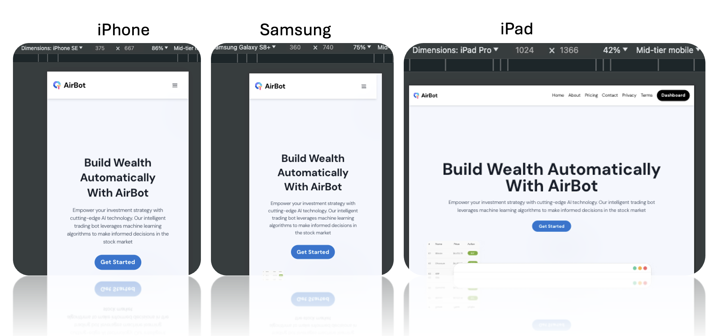

The navigation bar, depending on the screen size and your browser settings (to display desktop or mobile versions), is replaced by a "hamburger menu." When clicked, this menu displays the same options as the navigation bar, maintaining a layout that is more visible for your device's screen size.

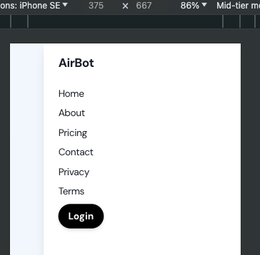

### Subscription and Payment methods

After entering your data, click on "Sign Up" to choose your plan and add funds to your account.

There are four aspects that differentiate the plans:

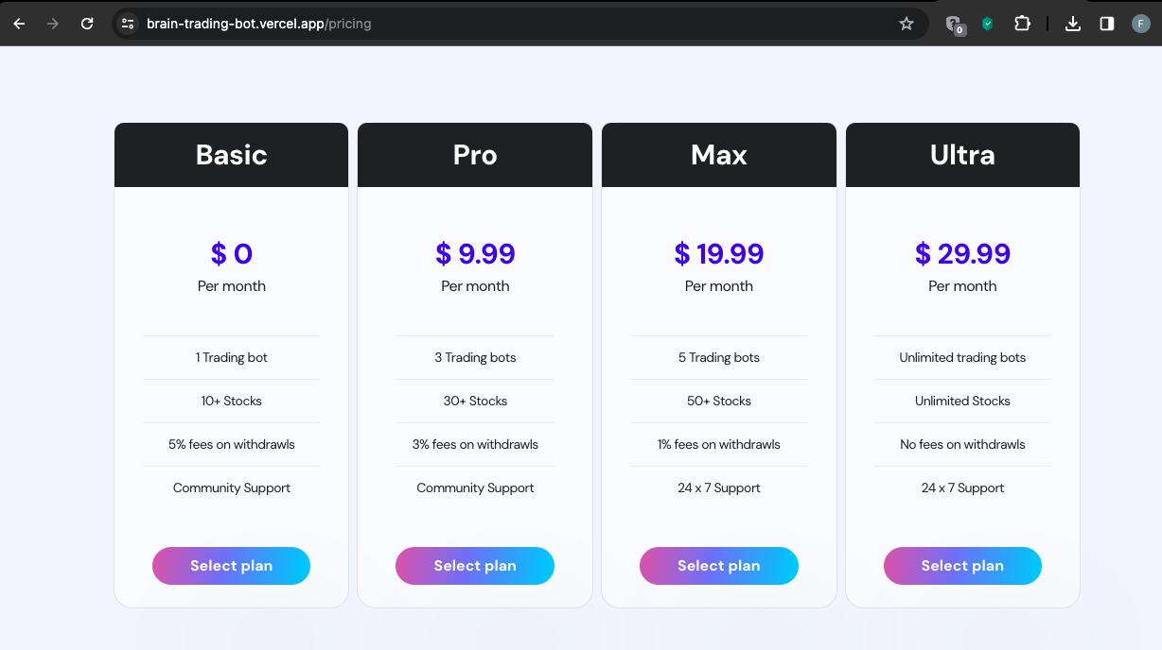

1. The **number of bots** you can register (single trading or multi-trading).

2. The **number of stocks available for trading**; in other words, the list of stocks depends on the plan you select.

3. **Fees**. A transaction fee is charged for each withdrawal, the value of which depends on the selected plan.

4. **Support**. Starting from the MAX plan, you can have 24x7 support from our team for any questions about the platform, issues, etc.

The value of the chosen plan will be charged monthly.

### Logged Session

Once you complete your registration or log in, you will be redirected to the logged-in area, specifically to the Dashboard page. Here are the sessions available for registered users:

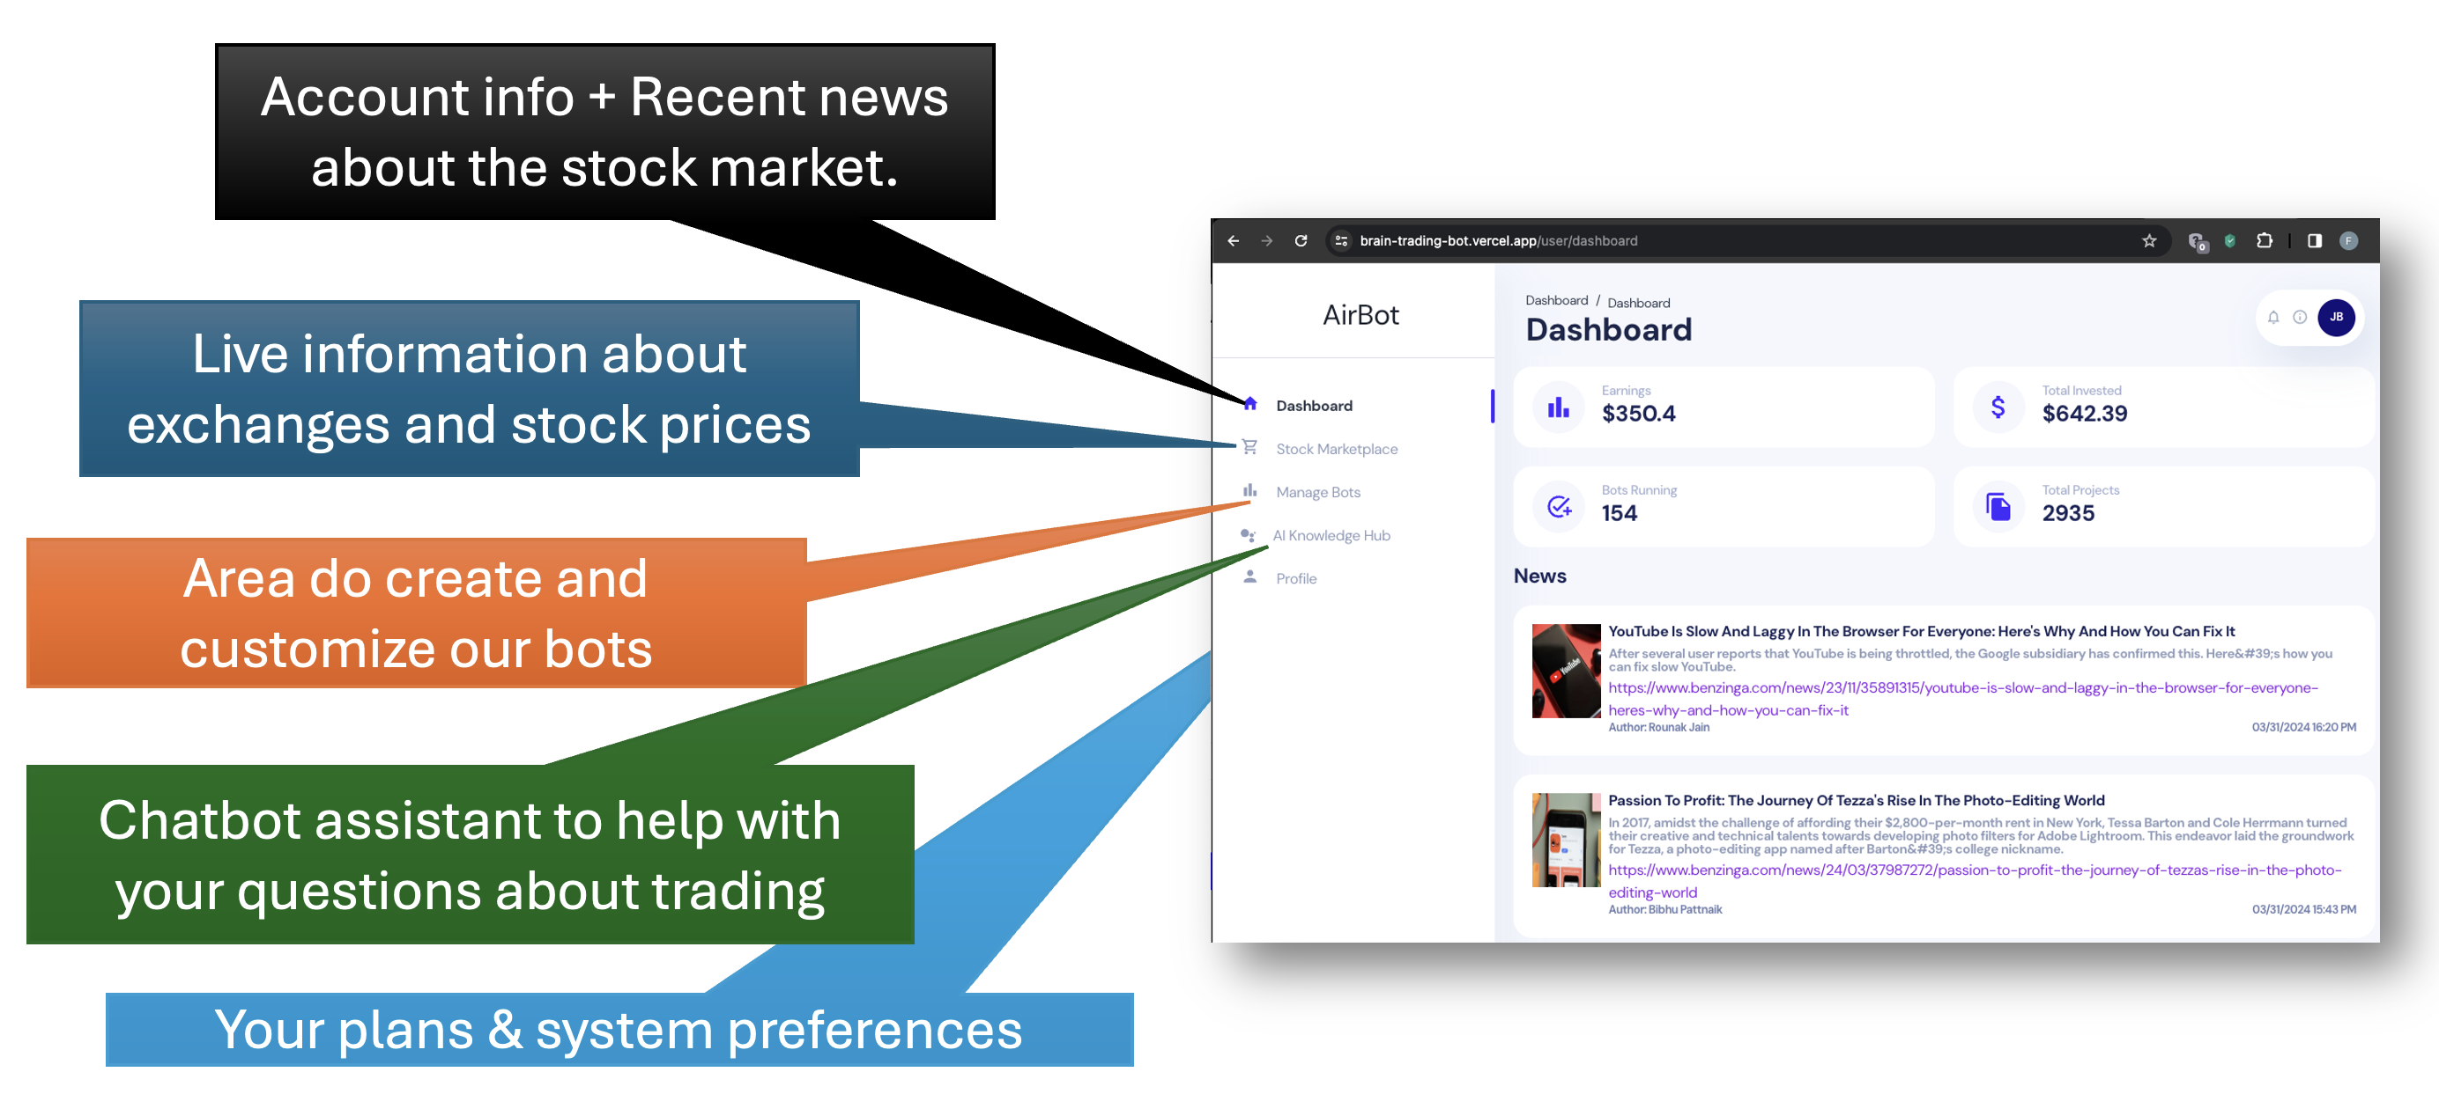

### Dashboard

As mentioned earlier, here you can find both a summary of your account information, such as the active number of bots, earnings, investments, etc., as well as navigate through the latest financial market news.

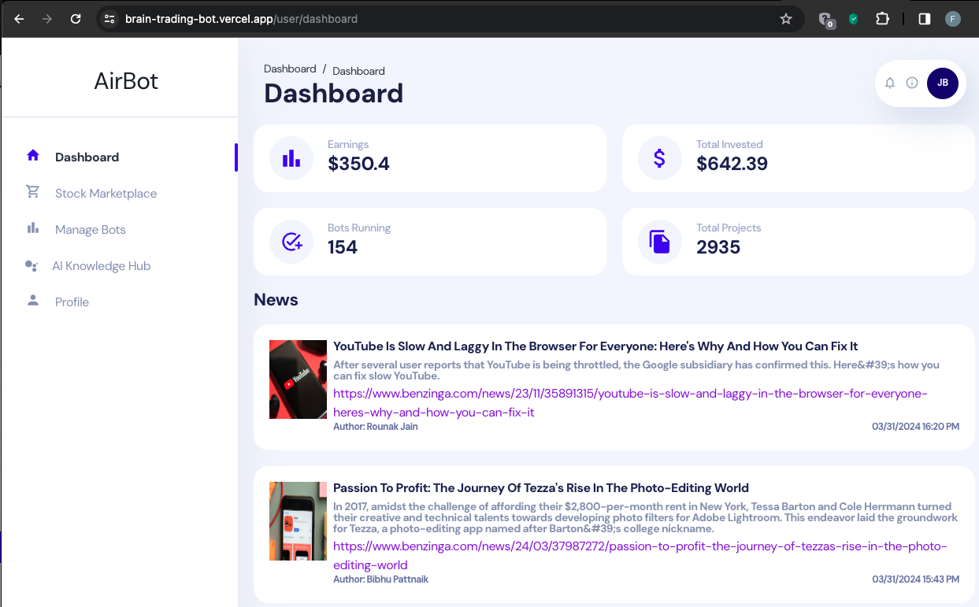

### Stock Marketplace

Here you can browse through a list of stocks from various exchanges and check their price status.

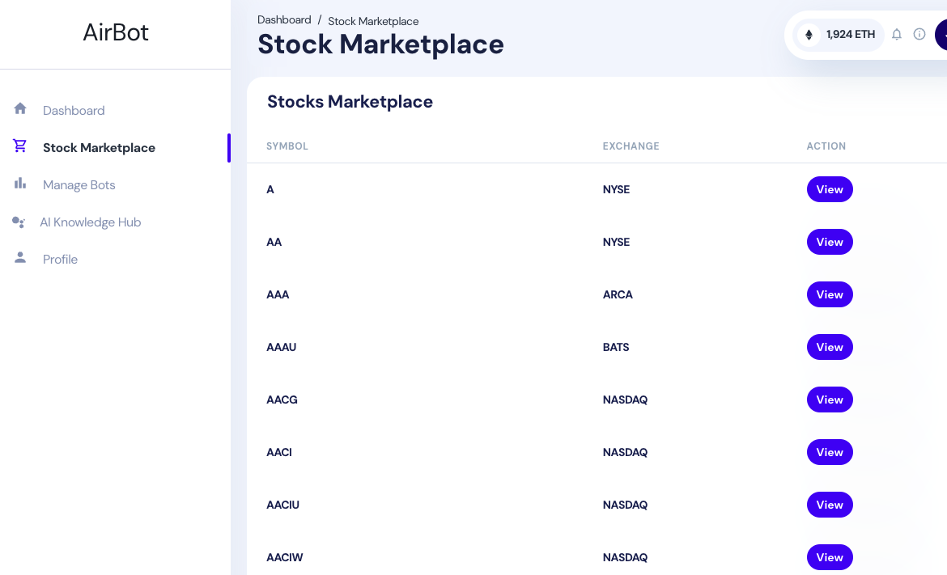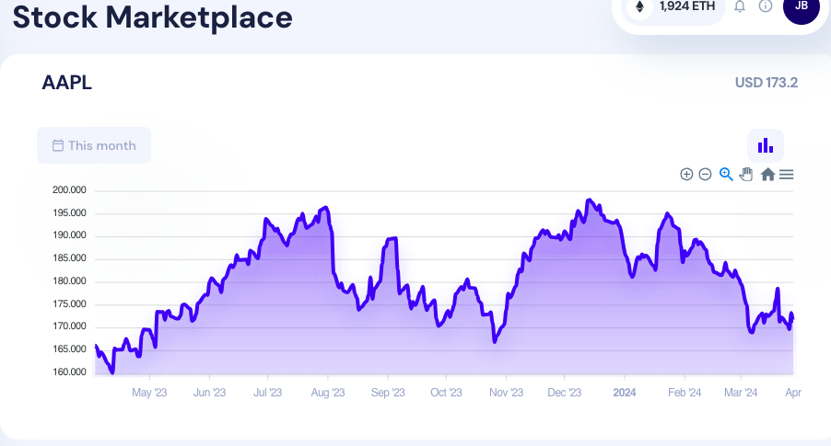

### Manage Bots

Here you can create, delete, and apply simulations on trading bots. You can start by clicking on the "Create Bot" button and customize your bot by filling out the options below.

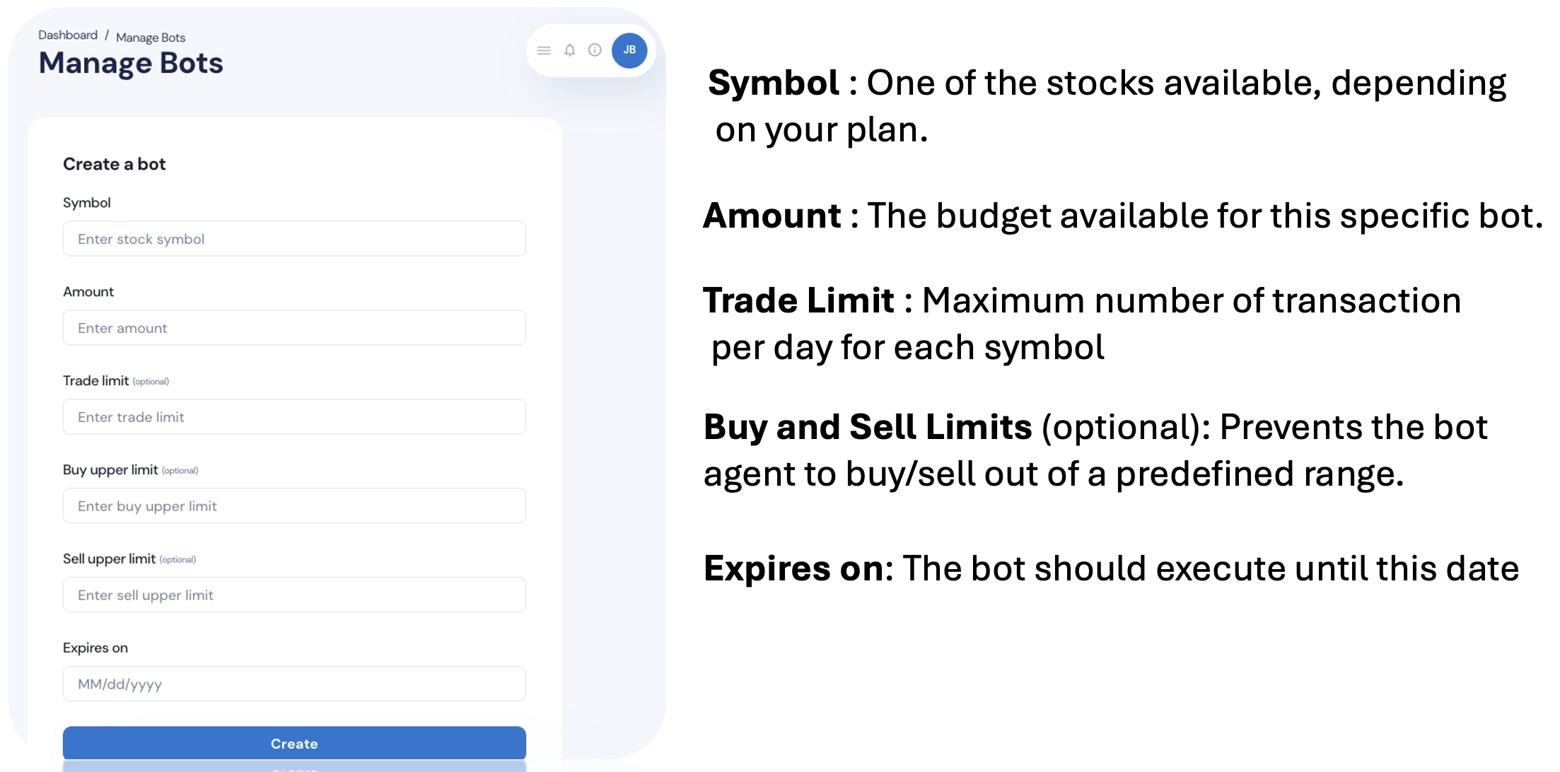

The trading agent bot will execute once a day through an automatic batch process that will perform trading actions, such as buying, selling, or "holding" stocks.

Depending on your plan, you may also choose the multi-paper option, where a stock portfolio is available to diversify your portfolio. If you choose a multi-paper option, the bot will manage your portfolio to optimize performance and value.

After creating your bot, you can navigate to the ACTION column and choose one of three options:

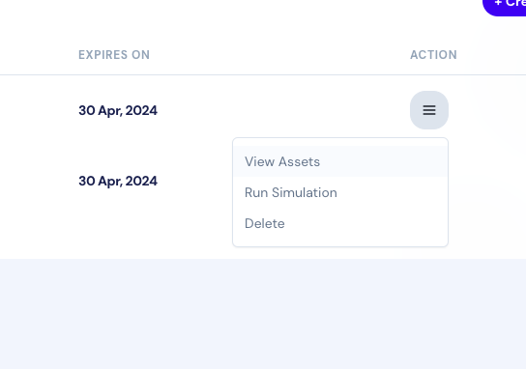

View Assets

History of buy and sell actions performed by the bot. You can track the number of shares for each stock symbol as well as its closing value on that day and how much fee was paid to the Exchange for that transaction.

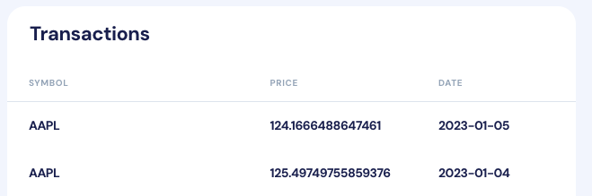

Run Simulation

You can simulate a run of your bot, for comparison and strategy validation purposes, applying the customized settings of the bot you registered on historical data, generating a simulated result of what your bot's performance would have been in that situation.

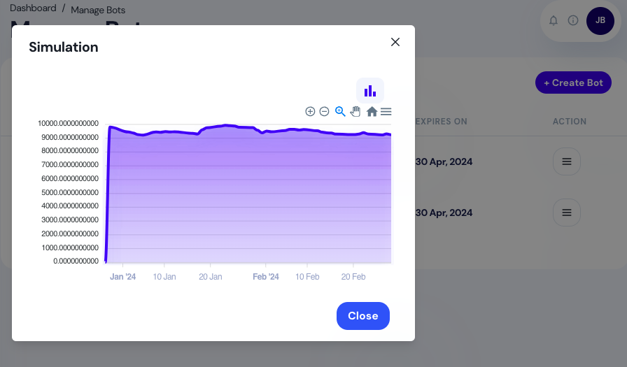

**Delete**: Removes your bot from the database, performing a logical deletion, so that historical data can be retained.

### AI Knowledge Hub

A chatbot for questions about stock marketing and system use. Simply say hi and start a chat with our Airbot. As the chatbot is only informational, it does not maintain the conversation session and does not "remember" what is being discussed in the AI Hub window.

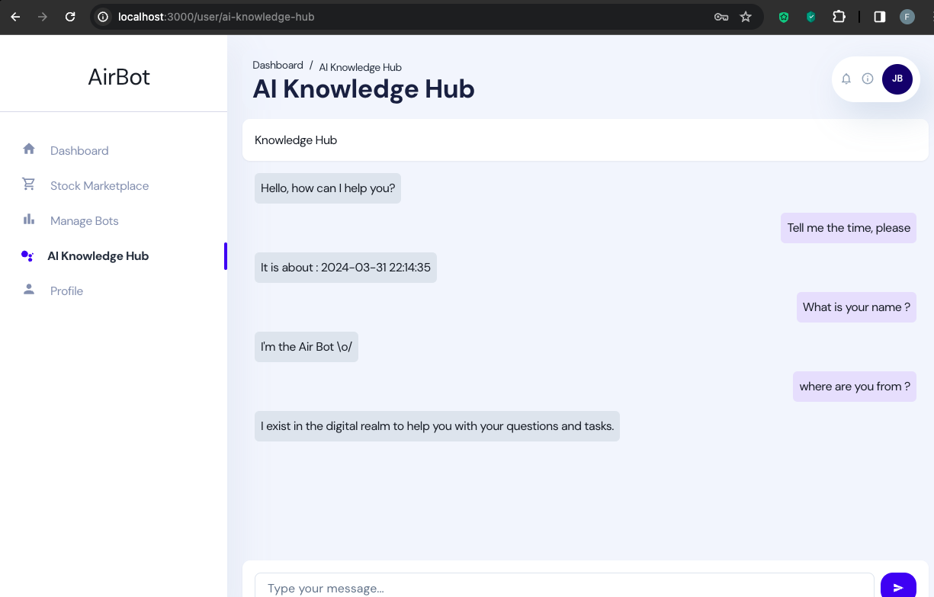

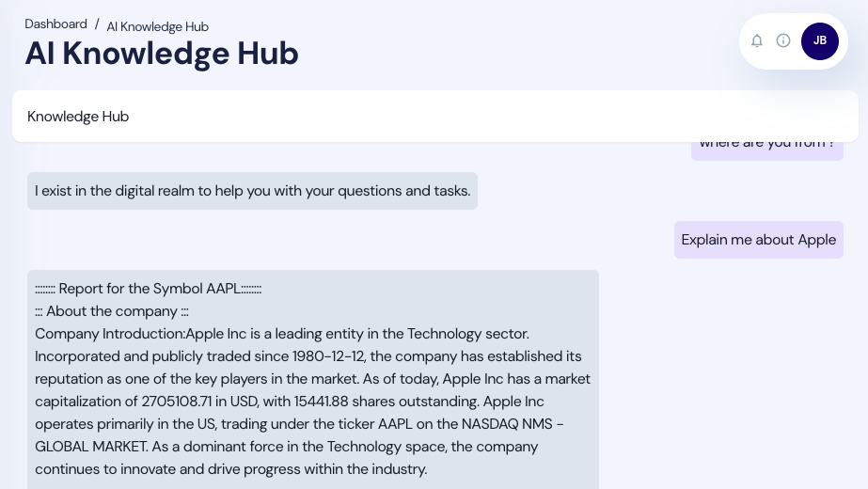

### Profile

In the profile section, you can review your registration data and change your plan.

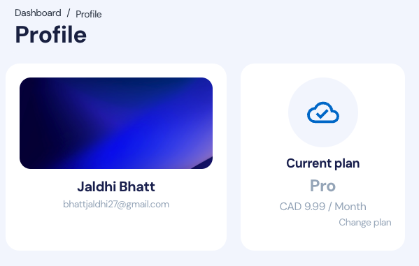

# Conclusion

## Wrapping up

We were able to grasp how powerful the approach of deep reinforcement learning is and its various applications. This was very instructive and clarifying, especially since we did not have this subject in our AI and Data Science course, opening doors to this potent AI tool.

Despite having researched the investment market, we understand that there are still many aspects that we possibly did not cover in our study and our solutions.

Nonetheless, we believe our work was fruitful; we managed to consolidate all the content of our research through our creativity in utilizing available technologies in a very promising automated trading solution.

In the end, we understand that our solution to try to democratize the use was successful, with just a few clicks, the user can create a long-term investment.

## Acknowledgement

We thank Mr. Stanley Chor, coordinator of the AIP, for his coaching and sharing his vast knowledge and experience, which helped and propelled us to give our best in this project.

We also thank our Project Advisor, Mr. Usman Ahmad, for guiding and directing us through this journey.

## Disclaimer

Once again, it is important to reinforce that this is a purely academic project. We do not intend to guarantee that this project, as it is, can be used in a real environment. Nor can we affirm or guarantee any kind of profit or that the project's applications are free from flaws, even though we have conducted several tests.

# Recommendation

We understand that there is much room for improvement. If we had more resources, we could work even more on training and optimizing our models, use an infrastructure more compatible with our applications, and, most importantly, explore more the legal aspects associated with trading done by AI automations. Although we understand that we are in compliance with legal standards, as per our research, we recognize that we are not qualified to have the final say on these aspects. Ideally, we would have a legal team to ensure the legality of our platform and operations.

We also understand that our AI knowledge hub feature, which was basically an extra feature we created alongside the stock trading bot, did not receive the attention it deserved. Despite achieving great results, it could be improved if we had access to computational resources to fine-tune our own LLM model instead of using third-party APIs to format our responses in the RAG implementation.

# References

1. Liu, X., Xia, Z., Yang, H., Gao, J., Zha, D., Zhu, M., Wang, C. D., Wang, Z., & Guo, J. (2023, April 25). Dynamic datasets and market environments for financial reinforcement learning. arXiv.org. <https://arxiv.org/abs/2304.13174>
2. Liu, X., Xia, Z., Rui, J., Gao, J., Yang, H., Zhu, M., Wang, C. D., Wang, Z., & Guo, J. (2022, November 6). FINRL-META: Market Environments and Benchmarks for Data-Driven Financial Reinforcement Learning. arXiv.org. <https://arxiv.org/abs/2211.03107>
3. Liu, X., Yang, H., Chen, Q., Zhang, R., Yang, L., Xiao, B., & Wang, C. D. (2020, November 19). FINRL: a deep reinforcement learning library for automated stock trading in quantitative finance. arXiv.org. https://arxiv.org/abs/2011.09607
4. King, R. (2023, May 10). Statistics and facts about the stock market. Finder Canada. <https://www.finder.com/ca/stock-trading/stock-trading-statistics>
5. Quickstart | Ngrok documentation. (2024, April 10). <https://ngrok.com/docs/getting-started>
6. Beginner’s Guide. (n.d.). <https://nginx.org/en/docs/beginners_guide.html>
7. Gunicorn - WSGI server — Gunicorn 21.2.0 documentation. (n.d.).   
   <https://docs.gunicorn.org/en/stable/>
8. IIROC Rules. (2024, March 18). IIROC. <https://www.iiroc.ca/rules-and-enforcement/iiroc-rules>
9. Quickstart — ElegantRL 0.3.1 documentation. (n.d.). <https://elegantrl.readthedocs.io/en/latest/helloworld/quickstart.html>
10. TMX Group. (n.d.-b). Market regulation. TSX.com. <https://www.tsx.com/trading/toronto-stock-exchange/trading-rules-and-regulations/market-regulation>
11. Investment dealer and partially consolidated rules. (2024, January 14). Canadian Investment Regulatory Organization.   
    https://www.ciro.ca/rules-and-enforcement/investment-dealer-and-partially-consolidated-rules
12. Beers, B. (2024b, March 18). How Long Does it Take for Brokers to Confirm a Trade? Investopedia. https://www.investopedia.com/ask/answers/112814/how-long-does-it-take-broker-confirm-trade-after-it-placed.asp

1. Hayes, A. (2023b, December 22). How does the stock market work? Investopedia. https://www.investopedia.com/articles/investing/082614/how-stock-market-works.asp

1. About us. (2024, April 2). Investopedia. https://www.investopedia.com/about-us-5093223

1. Plenty of individual investors are 'worried' about the stock market: Survey. (October 17, 2023). https://finance.yahoo.com/video/plenty-individual-investors-worried-stock-165022329.html

1. Beers, B. (2022, September 30). Why put money into a volatile stock market? Investopedia. https://www.investopedia.com/ask/answers/why-put-money-volatile-stock-market/

1. Team, I. (2023, November 27). How to trade the VIX: 4 Ways explained. Investopedia. https://www.investopedia.com/stock-analysis/2012/4-ways-to-trade-the-vix-vxx-vxz-tvix-xxv0504.aspx
2. Introduction — FinRL 0.3.1 documentation. (2021). https://finrl.readthedocs.io/en/latest/start/introduction.html

1. Deploying to Vercel. (2024). <https://vercel.com/docs/deployments/overview>
2. Tutorial: Get started with Amazon EC2 Linux instances - Amazon Elastic Compute Cloud. (2024.). <https://docs.aws.amazon.com/AWSEC2/latest/UserGuide/EC2_GetStarted.html>
3. About Broker API. (n.d.). Alpaca API Docs. <https://docs.alpaca.markets/docs/about-broker-api>
4. Generate API Reference | Legacy - Cohere Docs. (n.d.). Cohere AI. <https://docs.cohere.com/reference/generate>
5. Finnhub.Io. (n.d.). Finnhub - Free realtime APIs for stock, forex and cryptocurrency. <https://finnhub.io/docs/api>
6. Documentation. (n.d.). Firebase. <https://firebase.google.com/doc>
7. Yang, H. (Bruce), et al. (2023). FinGPT: Open-Source Financial Large Language Models. https://doi.org/10.48550/arXiv.2306.06031